Radar_Acc
Design Description

SJ

Radar_Acc: Design Description
지은이 SJ
펴냄 26-Jul-2020 23:24:34
저작권 © 2020
For Internal Distribution Only

차례
1장. Model Version 1
2장. Root System 2
Blocks 2
Parameters 2
Block Execution Order 2
3장. Subsystems 3
ACC Classical 3
Interface 3
Input Signals 3
Output Signals 4
Blocks 4
Parameters 4
"brake" (Outport) 4
"Longitudinal Velocity" (Inport) 5
"Relative Distance" (Inport) 6
"Relative Velocity" (Inport) 6
"throttle" (Outport) 7
Block Execution Order 8
Brake 8
Blocks 8
Parameters 8
"accel" (Inport) 8
"brake" (Outport) 8
Brake 10
Blocks 10
Parameters 10
"accel" (Inport) 10
"brake" (Outport) 10
"Constant1" (Constant) 11
"Gain" (Gain) 12
"Switch2" (Switch) 12
comparision:distance 14
Blocks 14
Parameters 14
"Default Spacing" (Constant) 14
"Difference_distance" (Outport) 15
"Longitudinal Velocity" (Inport) 16
"Product" (Product) 16
"Relative_distance" (Inport) 17
"Sum1" (Sum) 17
"Sum2" (Sum) 18
"Time Gap" (Constant) 19
Subsystem 19
Blocks 19
Parameters 19
"accel" (Inport) 19
"accel_limit" (Outport) 20
"Saturation1" (Saturate) 21
Subsystem 22
Blocks 22
Parameters 22
"accel" (Outport) 22
"From" (From) 23
"From1" (From) 23
"Goto" (Goto) 23
"Goto1" (Goto) 24
"Longitudinal Velocity" (Inport) 24
"Relative Velocity" (Inport) 24
"relative_distance" (Inport) 25
"Switch" (Switch) 25
Subsystem 26
Blocks 26
Parameters 26
"Difference_distance" (Inport) 26
"Difference_Velocity" (Outport) 27
"Gain2" (Gain) 28
"Gain3" (Gain) 28
"Relative_Velocity" (Inport) 29
"Sum3" (Sum) 29
Subsystem 30
Blocks 30
Parameters 30
"accel" (Inport) 30
"accel_limit" (Outport) 31
"Saturation" (Saturate) 32
Subsystem2 33
Blocks 33
Parameters 33
"Diffenece_Velocity" (Inport) 33
"Gain1" (Gain) 33
"Longitudinal Velocity" (Inport) 34
"Min" (MinMax) 34
"Min_Speed" (Outport) 35
"Set velocity" (Constant) 36
"Sum4" (Sum) 37
Throttle 37
Blocks 38
Parameters 38
"accel_limit" (Inport) 38
"Constant" (Constant) 38
"Switch1" (Switch) 39
"thro" (Outport) 39
throttle 41
Blocks 41
Parameters 41
"accel" (Inport) 41
"thtottle" (Outport) 41
4장. System Design Variables 43
Design Variable Summary 43
Design Variable Details 43
5장. Requirements 45
Model Information for "Radar_Acc" 45
Document Summary for "Radar_Acc" 45
System - ACC Classical 46
System - Brake 47
System - Subsystem 48
System - throttle 51
System - Brake 53
System - Subsystem 54
System - Subsystem 56
System - Subsystem2 58
System - comparision:distance 61
System - Subsystem 63
System - Throttle 64
6장. System Model Configuration 67
7장. Glossary 101
8장. About this Report 102
Report Overview 102
Root System Description 102
Subsystem Descriptions 103
State Chart Descriptions 103

표 목록
3-1. 3
3-2. 3
3-3. relative_distance 4
3-4. 4
3-5. 4
3-6. "brake" Parameters 4
3-7. "Longitudinal Velocity" Parameters 5
3-8. "Relative Distance" Parameters 6
3-9. "Relative Velocity" Parameters 6
3-10. "throttle" Parameters 7
3-11. "accel" Parameters 8
3-12. "brake" Parameters 8
3-13. "accel" Parameters 10
3-14. "brake" Parameters 10
3-15. "Constant1" Parameters 11
3-16. "Gain" Parameters 12
3-17. "Switch2" Parameters 12
3-18. "Default Spacing" Parameters 14
3-19. "Difference_distance" Parameters 15
3-20. "Longitudinal Velocity" Parameters 16
3-21. "Product" Parameters 16
3-22. "Relative_distance" Parameters 17
3-23. "Sum1" Parameters 17
3-24. "Sum2" Parameters 18
3-25. "Time Gap" Parameters 19
3-26. "accel" Parameters 19
3-27. "accel_limit" Parameters 20
3-28. "Saturation1" Parameters 21
3-29. "accel" Parameters 22
3-30. "From" Parameters 23
3-31. "From1" Parameters 23
3-32. "Goto" Parameters 23
3-33. "Goto1" Parameters 24
3-34. "Longitudinal Velocity" Parameters 24
3-35. "Relative Velocity" Parameters 24
3-36. "relative_distance" Parameters 25
3-37. "Switch" Parameters 25
3-38. "Difference_distance" Parameters 26
3-39. "Difference_Velocity" Parameters 27
3-40. "Gain2" Parameters 28
3-41. "Gain3" Parameters 28
3-42. "Relative_Velocity" Parameters 29
3-43. "Sum3" Parameters 29
3-44. "accel" Parameters 30
3-45. "accel_limit" Parameters 31
3-46. "Saturation" Parameters 32
3-47. "Diffenece_Velocity" Parameters 33
3-48. "Gain1" Parameters 33
3-49. "Longitudinal Velocity" Parameters 34
3-50. "Min" Parameters 34
3-51. "Min_Speed" Parameters 35
3-52. "Set velocity" Parameters 36
3-53. "Sum4" Parameters 37
3-54. "accel_limit" Parameters 38
3-55. "Constant" Parameters 38
3-56. "Switch1" Parameters 39
3-57. "thro" Parameters 39
3-58. "accel" Parameters 41
3-59. "thtottle" Parameters 41
4-1. Design Variables 43
5-1. Radar_Acc Version Information 45
5-2. Requirements documents linked in model 45
5-3. Blocks in "ACC Classical" that have requirements 46
5-4. Radar_Acc/ACC Classical/Brake Requirements 47
5-5. Blocks in "Brake" that have requirements 48
5-6. Radar_Acc/ACC Classical/Subsystem Requirements 49
5-7. Blocks in "Subsystem" that have requirements 49
5-8. Radar_Acc/ACC Classical/throttle Requirements 52
5-9. Blocks in "throttle " that have requirements 52
5-10. Radar_Acc/ACC Classical/Brake/Brake Requirements 53
5-11. Blocks in "Brake" that have requirements 53
5-12. Radar_Acc/ACC Classical/Brake/Subsystem Requirements 55
5-13. Blocks in "Subsystem" that have requirements 55
5-14. Radar_Acc/ACC Classical/Subsystem/Subsystem Requirements 56
5-15. Blocks in "Subsystem" that have requirements 56
5-16. Radar_Acc/ACC Classical/Subsystem/Subsystem2 Requirements 59
5-17. Blocks in "Subsystem2" that have requirements 59
5-18. Radar_Acc/ACC Classical/Subsystem/comparision:distance Requirements 61
5-19. Blocks in "comparision:distance" that have requirements 61
5-20. Radar_Acc/ACC Classical/throttle /Subsystem Requirements 63
5-21. Blocks in "Subsystem" that have requirements 64
5-22. Radar_Acc/ACC Classical/throttle /Throttle Requirements 65
5-23. Blocks in "Throttle" that have requirements 65
6-1. Radar_Acc Configuration Set 67
6-2. Radar_Acc Configuration Set.Components [67] (1) 67
6-3. Radar_Acc Configuration Set.Components [67] (2) 69
6-4. Radar_Acc Configuration Set.Components [67] (3) 70
6-5. Radar_Acc Configuration Set.Components [67] (4) 72
6-6. Radar_Acc Configuration Set.Components [67] (5) 75
6-7. Radar_Acc Configuration Set.Components [67] (6) 77
6-8. Radar_Acc Configuration Set.Components [67] (7) 77
6-9. Radar_Acc Configuration Set.Components [67] (8) 78
6-10. Radar_Acc Configuration Set.Components [67] (9) 81
6-11. Radar_Acc Configuration Set.Components [67] (10) 82
6-12. Radar_Acc Configuration Set.Components(8) [78] .CodeCoverageSettings 83
6-13. Radar_Acc Configuration Set.Components(8).Components [81] (1) 83
6-14. Radar_Acc Configuration Set.Components(8).Components [81] (2) 85
6-15. Radar_Acc Configuration Set.Components(8).Components(2) [85] .ReplacementTypes 89
6-16. HDL Coder 89

그림 목록
2-1. Radar_Acc 2
3-1. Radar_Acc/ACC Classical 3
3-2. Radar_Acc/ACC Classical/Brake 8
3-3. Radar_Acc/ACC Classical/Brake/Brake 10
3-4. Radar_Acc/ACC Classical/Subsystem/comparision:distance 14
3-5. Radar_Acc/ACC Classical/Brake/Subsystem 19
3-6. Radar_Acc/ACC Classical/Subsystem 22
3-7. Radar_Acc/ACC Classical/Subsystem/Subsystem 26
3-8. Radar_Acc/ACC Classical/throttle /Subsystem 30
3-9. Radar_Acc/ACC Classical/Subsystem/Subsystem2 33
3-10. Radar_Acc/ACC Classical/throttle /Throttle 37
3-11. Radar_Acc/ACC Classical/throttle 41

1장. Model Version
Version: 1.7
Last modified: Sun Jul 26 23:00:24 2020
Checksum: Could not compute checksum for "Radar_Acc" (possibly because model could not be compiled).

2장. Root System
그림 2-1. Radar_Acc
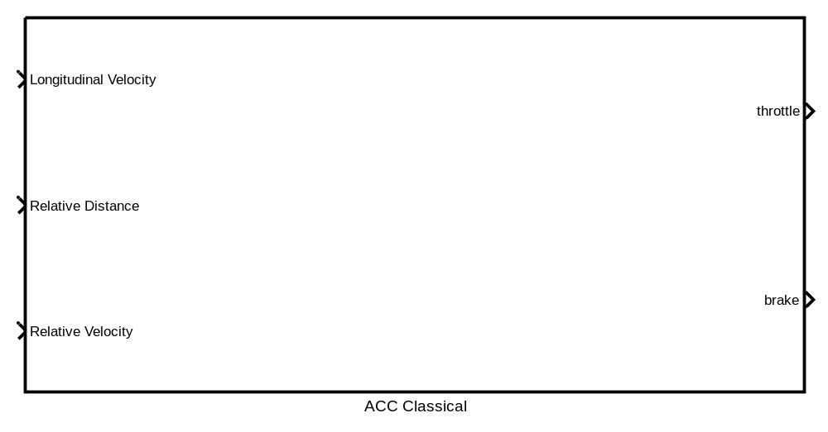

Blocks

Parameters

Block Execution Order

3장. Subsystems

ACC Classical
Checksum: Could not compute checksum for "Radar_Acc/ACC Classical" (possibly because model could not be compiled).
그림 3-1. Radar_Acc/ACC Classical
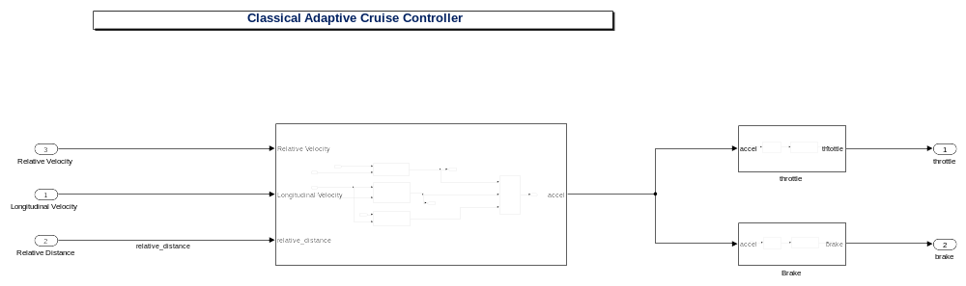

Interface

Input Signals
The following tables describe external signals used to compute the subsystem's inputs.The name of the input signal is the name of the input port that accepts the signal. The number in angle brackets is the number of the input port. A dimension of [1 1] indicates a scalar signal.
표 3-1.
Description:
Data Type:
Width: 0
Dimensions:

표 3-2.
Description:
Data Type:
Width: 0
Dimensions:

표 3-3. relative_distance
Description:
Data Type:
Width: 0
Dimensions:

Output Signals
The following tables describe the signals output by this system. The name of the output signal is the name of the signal's parent block, i.e., the block that computes the signal. The number in angle brackets is the number of the port that emits the signal.
표 3-4.
Description:
Data Type:
Width: 0
Dimensions:

표 3-5.
Description:
Data Type:
Width: 0
Dimensions:

Blocks

Parameters

"brake" (Outport)
표 3-6. "brake" Parameters
Parameter | Value
Port number | 2
Icon display | Port number
Minimum | []
Maximum | []
Data type | Inherit: auto
Lock output data type setting against changes by the fixed-point tools | off
Output as nonvirtual bus in parent model | off
Unit (e.g., m, m/s^2, N*m) | inherit
Port dimensions (-1 for inherited) | -1
Variable-size signal | Inherit
Sample time (-1 for inherited) | -1
Ensure outport is virtual | off
Source of initial output value | Dialog
Output when disabled | held
Initial output | []
MustResolveToSignalObject | off
Specify output when source is unconnected | off
Constant value | 0
Interpret vector parameters as 1-D | off

"Longitudinal Velocity" (Inport)
표 3-7. "Longitudinal Velocity" Parameters
Parameter | Value
Port number | 1
Port dimensions (-1 for inherited) | -1
Sample time (-1 for inherited) | -1
Minimum | []
Maximum | []
Data type | Inherit: auto

"Relative Distance" (Inport)
표 3-8. "Relative Distance" Parameters
Parameter | Value
Port number | 2
Port dimensions (-1 for inherited) | -1
Sample time (-1 for inherited) | -1
Minimum | []
Maximum | []
Data type | Inherit: auto

"Relative Velocity" (Inport)
표 3-9. "Relative Velocity" Parameters
Parameter | Value
Port number | 3
Port dimensions (-1 for inherited) | -1
Sample time (-1 for inherited) | -1
Minimum | []
Maximum | []
Data type | Inherit: auto

"throttle" (Outport)
표 3-10. "throttle" Parameters
Parameter | Value
Port number | 1
Icon display | Port number
Minimum | []
Maximum | []
Data type | Inherit: auto
Lock output data type setting against changes by the fixed-point tools | off
Output as nonvirtual bus in parent model | off
Unit (e.g., m, m/s^2, N*m) | inherit
Port dimensions (-1 for inherited) | -1
Variable-size signal | Inherit
Sample time (-1 for inherited) | -1
Ensure outport is virtual | off
Source of initial output value | Dialog
Output when disabled | held
Initial output | []
MustResolveToSignalObject | off
Specify output when source is unconnected | off
Constant value | 0
Interpret vector parameters as 1-D | off

Block Execution Order

Brake
그림 3-2. Radar_Acc/ACC Classical/Brake
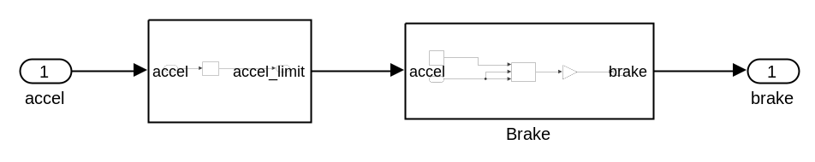

Blocks

Parameters

"accel" (Inport)
표 3-11. "accel" Parameters
Parameter | Value
Port number | 1
Port dimensions (-1 for inherited) | -1
Sample time (-1 for inherited) | -1
Minimum | []
Maximum | []
Data type | Inherit: auto

"brake" (Outport)
표 3-12. "brake" Parameters
Parameter | Value
Port number | 1
Icon display | Port number
Minimum | []
Maximum | []
Data type | Inherit: auto
Lock output data type setting against changes by the fixed-point tools | off
Output as nonvirtual bus in parent model | off
Unit (e.g., m, m/s^2, N*m) | inherit
Port dimensions (-1 for inherited) | -1
Variable-size signal | Inherit
Sample time (-1 for inherited) | -1
Ensure outport is virtual | off
Source of initial output value | Dialog
Output when disabled | held
Initial output | []
MustResolveToSignalObject | off
Specify output when source is unconnected | off
Constant value | 0
Interpret vector parameters as 1-D | off

Brake
그림 3-3. Radar_Acc/ACC Classical/Brake/Brake
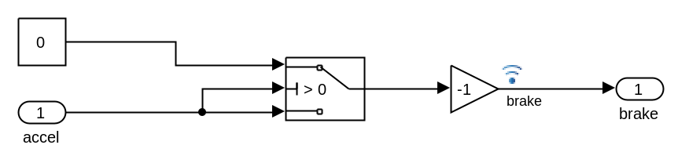

Blocks

Parameters

"accel" (Inport)
표 3-13. "accel" Parameters
Parameter | Value
Port number | 1
Port dimensions (-1 for inherited) | -1
Sample time (-1 for inherited) | -1
Minimum | []
Maximum | []
Data type | Inherit: auto

"brake" (Outport)
표 3-14. "brake" Parameters
Parameter | Value
Port number | 1
Icon display | Port number
Minimum | []
Maximum | []
Data type | Inherit: auto
Lock output data type setting against changes by the fixed-point tools | off
Output as nonvirtual bus in parent model | off
Unit (e.g., m, m/s^2, N*m) | inherit
Port dimensions (-1 for inherited) | -1
Variable-size signal | Inherit
Sample time (-1 for inherited) | -1
Ensure outport is virtual | off
Source of initial output value | Dialog
Output when disabled | held
Initial output | []
MustResolveToSignalObject | off
Specify output when source is unconnected | off
Constant value | 0
Interpret vector parameters as 1-D | off

"Constant1" (Constant)
표 3-15. "Constant1" Parameters
Parameter | Value
Constant value | 0
Interpret vector parameters as 1-D | on
Output minimum | []
Output maximum | []
Output data type | Inherit: Inherit from 'Constant value'
Lock output data type setting against changes by the fixed-point tools | off
Sample time | inf
Frame period | inf

"Gain" (Gain)
표 3-16. "Gain" Parameters
Parameter | Value
Gain | -1
Multiplication | Element-wise(K.*u)
Parameter minimum | []
Parameter maximum | []
Parameter data type | Inherit: Inherit via internal rule
Output minimum | []
Output maximum | []
Output data type | Inherit: Inherit via internal rule
Lock output data type setting against changes by the fixed-point tools | off
Integer rounding mode | Floor
Saturate on integer overflow | off
Sample time (-1 for inherited) | -1

"Switch2" (Switch)
표 3-17. "Switch2" Parameters
Parameter | Value
Criteria for passing first input | u2 > Threshold
Threshold | 0
Require all data port inputs to have the same data type | off
Output minimum | []
Output maximum | []
Output data type | Inherit: Inherit via internal rule
Lock output data type setting against changes by the fixed-point tools | off
Integer rounding mode | Floor
Saturate on integer overflow | off
Enable zero-crossing detection | on
Sample time (-1 for inherited) | -1
Allow different data input sizes (Results in variable-size output signal) | off

comparision:distance
그림 3-4. Radar_Acc/ACC Classical/Subsystem/comparision:distance
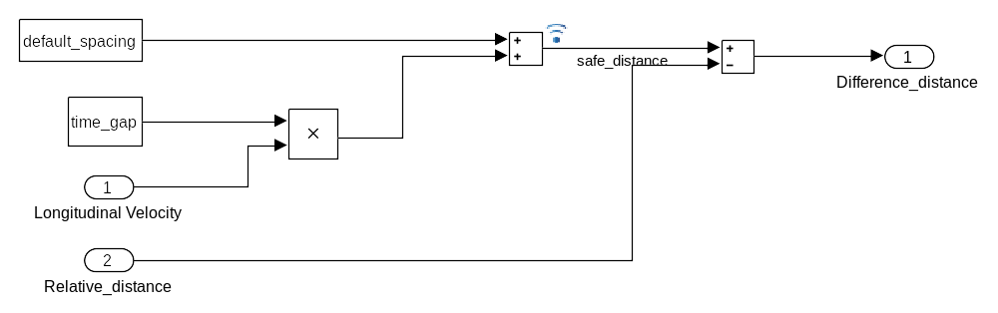

Blocks

Parameters

"Default Spacing" (Constant)
표 3-18. "Default Spacing" Parameters
Parameter | Value
Constant value | default_spacing
Interpret vector parameters as 1-D | on
Output minimum | []
Output maximum | []
Output data type | Inherit: Inherit from 'Constant value'
Lock output data type setting against changes by the fixed-point tools | off
Sample time | Ts
Frame period | inf

"Difference_distance" (Outport)
표 3-19. "Difference_distance" Parameters
Parameter | Value
Port number | 1
Icon display | Port number
Minimum | []
Maximum | []
Data type | Inherit: auto
Lock output data type setting against changes by the fixed-point tools | off
Output as nonvirtual bus in parent model | off
Unit (e.g., m, m/s^2, N*m) | inherit
Port dimensions (-1 for inherited) | -1
Variable-size signal | Inherit
Sample time (-1 for inherited) | -1
Ensure outport is virtual | off
Source of initial output value | Dialog
Output when disabled | held
Initial output | []
MustResolveToSignalObject | off
Specify output when source is unconnected | off
Constant value | 0
Interpret vector parameters as 1-D | off

"Longitudinal Velocity" (Inport)
표 3-20. "Longitudinal Velocity" Parameters
Parameter | Value
Port number | 1
Port dimensions (-1 for inherited) | -1
Sample time (-1 for inherited) | -1
Minimum | []
Maximum | []
Data type | Inherit: auto

"Product" (Product)
표 3-21. "Product" Parameters
Parameter | Value
Number of inputs | 2
Multiplication | Element-wise(.*)
Multiply over | All dimensions
Dimension | 1
Require all inputs to have the same data type | off
Output minimum | []
Output maximum | []
Output data type | Inherit: Inherit via internal rule
Lock output data type setting against changes by the fixed-point tools | off
Integer rounding mode | Floor
Saturate on integer overflow | off
Sample time (-1 for inherited) | -1

"Relative_distance" (Inport)
표 3-22. "Relative_distance" Parameters
Parameter | Value
Port number | 2
Port dimensions (-1 for inherited) | -1
Sample time (-1 for inherited) | -1
Minimum | []
Maximum | []
Data type | Inherit: auto

"Sum1" (Sum)
표 3-23. "Sum1" Parameters
Parameter | Value
Icon shape | rectangular
List of signs | +-
Sum over | All dimensions
Dimension | 1
Require all inputs to have the same data type | off
Accumulator data type | Inherit: Inherit via internal rule
Output minimum | []
Output maximum | []
Output data type | Inherit: Inherit via internal rule
Lock data type settings against changes by the fixed-point tools | off
Integer rounding mode | Floor
Saturate on integer overflow | off
Sample time (-1 for inherited) | -1

"Sum2" (Sum)
표 3-24. "Sum2" Parameters
Parameter | Value
Icon shape | rectangular
List of signs | ++
Sum over | All dimensions
Dimension | 1
Require all inputs to have the same data type | off
Accumulator data type | Inherit: Inherit via internal rule
Output minimum | []
Output maximum | []
Output data type | Inherit: Inherit via internal rule
Lock data type settings against changes by the fixed-point tools | off
Integer rounding mode | Floor
Saturate on integer overflow | off
Sample time (-1 for inherited) | -1

"Time Gap" (Constant)
표 3-25. "Time Gap" Parameters
Parameter | Value
Constant value | time_gap
Interpret vector parameters as 1-D | on
Output minimum | []
Output maximum | []
Output data type | Inherit: Inherit from 'Constant value'
Lock output data type setting against changes by the fixed-point tools | off
Sample time | Ts
Frame period | inf

Subsystem
그림 3-5. Radar_Acc/ACC Classical/Brake/Subsystem
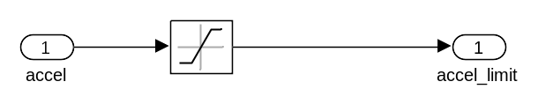

Blocks

Parameters

"accel" (Inport)
표 3-26. "accel" Parameters
Parameter | Value
Port number | 1
Port dimensions (-1 for inherited) | -1
Sample time (-1 for inherited) | -1
Minimum | []
Maximum | []
Data type | Inherit: auto

"accel_limit" (Outport)
표 3-27. "accel_limit" Parameters
Parameter | Value
Port number | 1
Icon display | Port number
Minimum | []
Maximum | []
Data type | Inherit: auto
Lock output data type setting against changes by the fixed-point tools | off
Output as nonvirtual bus in parent model | off
Unit (e.g., m, m/s^2, N*m) | inherit
Port dimensions (-1 for inherited) | -1
Variable-size signal | Inherit
Sample time (-1 for inherited) | -1
Ensure outport is virtual | off
Source of initial output value | Dialog
Output when disabled | held
Initial output | []
MustResolveToSignalObject | off
Specify output when source is unconnected | off
Constant value | 0
Interpret vector parameters as 1-D | off

"Saturation1" (Saturate)
표 3-28. "Saturation1" Parameters
Parameter | Value
Upper limit | 1
Lower limit | -10
Treat as gain when linearizing | on
Enable zero-crossing detection | on
Sample time (-1 for inherited) | -1
Output minimum | []
Output maximum | []
Output data type | Inherit: Same as input
Lock output data type setting against changes by the fixed-point tools | off
Integer rounding mode | Floor

Subsystem
그림 3-6. Radar_Acc/ACC Classical/Subsystem
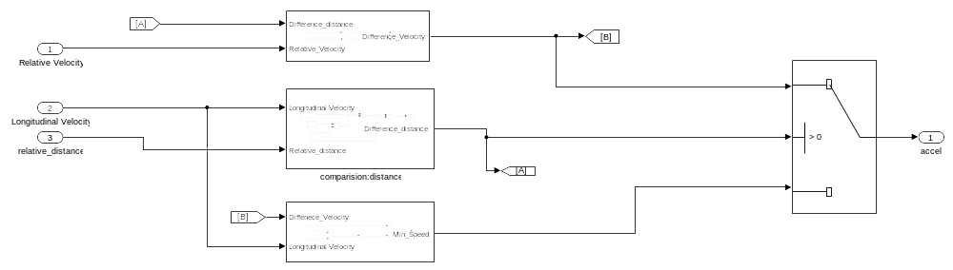

Blocks

Parameters

"accel" (Outport)
표 3-29. "accel" Parameters
Parameter | Value
Port number | 1
Icon display | Port number
Minimum | []
Maximum | []
Data type | Inherit: auto
Lock output data type setting against changes by the fixed-point tools | off
Output as nonvirtual bus in parent model | off
Unit (e.g., m, m/s^2, N*m) | inherit
Port dimensions (-1 for inherited) | -1
Variable-size signal | Inherit
Sample time (-1 for inherited) | -1
Ensure outport is virtual | off
Source of initial output value | Dialog
Output when disabled | held
Initial output | []
MustResolveToSignalObject | off
Specify output when source is unconnected | off
Constant value | 0
Interpret vector parameters as 1-D | off

"From" (From)
표 3-30. "From" Parameters
Parameter | Value
Goto tag | A
Icon display | Tag

"From1" (From)
표 3-31. "From1" Parameters
Parameter | Value
Goto tag | B
Icon display | Tag

"Goto" (Goto)
표 3-32. "Goto" Parameters
Parameter | Value
Tag | A
Icon display | Tag
Tag visibility | local

"Goto1" (Goto)
표 3-33. "Goto1" Parameters
Parameter | Value
Tag | B
Icon display | Tag
Tag visibility | local

"Longitudinal Velocity" (Inport)
표 3-34. "Longitudinal Velocity" Parameters
Parameter | Value
Port number | 2
Port dimensions (-1 for inherited) | -1
Sample time (-1 for inherited) | -1
Minimum | []
Maximum | []
Data type | Inherit: auto

"Relative Velocity" (Inport)
표 3-35. "Relative Velocity" Parameters
Parameter | Value
Port number | 1
Port dimensions (-1 for inherited) | -1
Sample time (-1 for inherited) | -1
Minimum | []
Maximum | []
Data type | Inherit: auto

"relative_distance" (Inport)
표 3-36. "relative_distance" Parameters
Parameter | Value
Port number | 3
Port dimensions (-1 for inherited) | -1
Sample time (-1 for inherited) | -1
Minimum | []
Maximum | []
Data type | Inherit: auto

"Switch" (Switch)
표 3-37. "Switch" Parameters
Parameter | Value
Criteria for passing first input | u2 > Threshold
Threshold | 0
Require all data port inputs to have the same data type | off
Output minimum | []
Output maximum | []
Output data type | Inherit: Inherit via internal rule
Lock output data type setting against changes by the fixed-point tools | off
Integer rounding mode | Floor
Saturate on integer overflow | off
Enable zero-crossing detection | on
Sample time (-1 for inherited) | -1
Allow different data input sizes (Results in variable-size output signal) | off

Subsystem
그림 3-7. Radar_Acc/ACC Classical/Subsystem/Subsystem
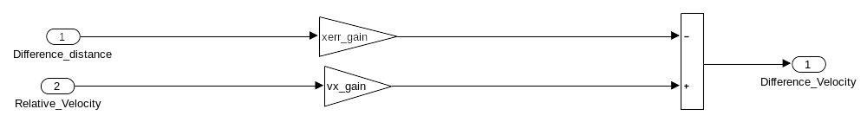

Blocks

Parameters

"Difference_distance" (Inport)
표 3-38. "Difference_distance" Parameters
Parameter | Value
Port number | 1
Port dimensions (-1 for inherited) | -1
Sample time (-1 for inherited) | -1
Minimum | []
Maximum | []
Data type | Inherit: auto

"Difference_Velocity" (Outport)
표 3-39. "Difference_Velocity" Parameters
Parameter | Value
Port number | 1
Icon display | Port number
Minimum | []
Maximum | []
Data type | Inherit: auto
Lock output data type setting against changes by the fixed-point tools | off
Output as nonvirtual bus in parent model | off
Unit (e.g., m, m/s^2, N*m) | inherit
Port dimensions (-1 for inherited) | -1
Variable-size signal | Inherit
Sample time (-1 for inherited) | -1
Ensure outport is virtual | off
Source of initial output value | Dialog
Output when disabled | held
Initial output | []
MustResolveToSignalObject | off
Specify output when source is unconnected | off
Constant value | 0
Interpret vector parameters as 1-D | off

"Gain2" (Gain)
표 3-40. "Gain2" Parameters
Parameter | Value
Gain | xerr_gain
Multiplication | Element-wise(K.*u)
Parameter minimum | []
Parameter maximum | []
Parameter data type | Inherit: Inherit via internal rule
Output minimum | []
Output maximum | []
Output data type | Inherit: Inherit via internal rule
Lock output data type setting against changes by the fixed-point tools | off
Integer rounding mode | Floor
Saturate on integer overflow | off
Sample time (-1 for inherited) | -1

"Gain3" (Gain)
표 3-41. "Gain3" Parameters
Parameter | Value
Gain | vx_gain
Multiplication | Element-wise(K.*u)
Parameter minimum | []
Parameter maximum | []
Parameter data type | Inherit: Inherit via internal rule
Output minimum | []
Output maximum | []
Output data type | Inherit: Inherit via internal rule
Lock output data type setting against changes by the fixed-point tools | off
Integer rounding mode | Floor
Saturate on integer overflow | off
Sample time (-1 for inherited) | -1

"Relative_Velocity" (Inport)
표 3-42. "Relative_Velocity" Parameters
Parameter | Value
Port number | 2
Port dimensions (-1 for inherited) | -1
Sample time (-1 for inherited) | -1
Minimum | []
Maximum | []
Data type | Inherit: auto

"Sum3" (Sum)
표 3-43. "Sum3" Parameters
Parameter | Value
Icon shape | rectangular
List of signs | -+
Sum over | All dimensions
Dimension | 1
Require all inputs to have the same data type | off
Accumulator data type | Inherit: Inherit via internal rule
Output minimum | []
Output maximum | []
Output data type | Inherit: Inherit via internal rule
Lock data type settings against changes by the fixed-point tools | off
Integer rounding mode | Floor
Saturate on integer overflow | off
Sample time (-1 for inherited) | -1

Subsystem
그림 3-8. Radar_Acc/ACC Classical/throttle /Subsystem
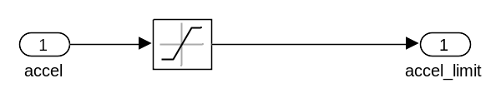

Blocks

Parameters

"accel" (Inport)
표 3-44. "accel" Parameters
Parameter | Value
Port number | 1
Port dimensions (-1 for inherited) | -1
Sample time (-1 for inherited) | -1
Minimum | []
Maximum | []
Data type | Inherit: auto

"accel_limit" (Outport)
표 3-45. "accel_limit" Parameters
Parameter | Value
Port number | 1
Icon display | Port number
Minimum | []
Maximum | []
Data type | Inherit: auto
Lock output data type setting against changes by the fixed-point tools | off
Output as nonvirtual bus in parent model | off
Unit (e.g., m, m/s^2, N*m) | inherit
Port dimensions (-1 for inherited) | -1
Variable-size signal | Inherit
Sample time (-1 for inherited) | -1
Ensure outport is virtual | off
Source of initial output value | Dialog
Output when disabled | held
Initial output | []
MustResolveToSignalObject | off
Specify output when source is unconnected | off
Constant value | 0
Interpret vector parameters as 1-D | off

"Saturation" (Saturate)
표 3-46. "Saturation" Parameters
Parameter | Value
Upper limit | 1
Lower limit | -10
Treat as gain when linearizing | on
Enable zero-crossing detection | on
Sample time (-1 for inherited) | -1
Output minimum | []
Output maximum | []
Output data type | Inherit: Same as input
Lock output data type setting against changes by the fixed-point tools | off
Integer rounding mode | Floor

Subsystem2
그림 3-9. Radar_Acc/ACC Classical/Subsystem/Subsystem2
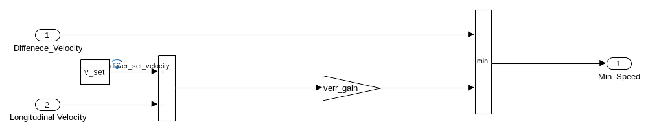

Blocks

Parameters

"Diffenece_Velocity" (Inport)
표 3-47. "Diffenece_Velocity" Parameters
Parameter | Value
Port number | 1
Port dimensions (-1 for inherited) | -1
Sample time (-1 for inherited) | -1
Minimum | []
Maximum | []
Data type | Inherit: auto

"Gain1" (Gain)
표 3-48. "Gain1" Parameters
Parameter | Value
Gain | verr_gain
Multiplication | Element-wise(K.*u)
Parameter minimum | []
Parameter maximum | []
Parameter data type | Inherit: Inherit via internal rule
Output minimum | []
Output maximum | []
Output data type | Inherit: Inherit via internal rule
Lock output data type setting against changes by the fixed-point tools | off
Integer rounding mode | Floor
Saturate on integer overflow | off
Sample time (-1 for inherited) | -1

"Longitudinal Velocity" (Inport)
표 3-49. "Longitudinal Velocity" Parameters
Parameter | Value
Port number | 2
Port dimensions (-1 for inherited) | -1
Sample time (-1 for inherited) | -1
Minimum | []
Maximum | []
Data type | Inherit: auto

"Min" (MinMax)
표 3-50. "Min" Parameters
Parameter | Value
Function | min
Number of input ports | 2
Require all inputs to have the same data type | off
Output minimum | []
Output maximum | []
Output data type | Inherit: Inherit via internal rule
Lock output data type setting against changes by the fixed-point tools | off
Integer rounding mode | Floor
Saturate on integer overflow | off
Enable zero-crossing detection | on
Sample time (-1 for inherited) | -1

"Min_Speed" (Outport)
표 3-51. "Min_Speed" Parameters
Parameter | Value
Port number | 1
Icon display | Port number
Minimum | []
Maximum | []
Data type | Inherit: auto
Lock output data type setting against changes by the fixed-point tools | off
Output as nonvirtual bus in parent model | off
Unit (e.g., m, m/s^2, N*m) | inherit
Port dimensions (-1 for inherited) | -1
Variable-size signal | Inherit
Sample time (-1 for inherited) | -1
Ensure outport is virtual | off
Source of initial output value | Dialog
Output when disabled | held
Initial output | []
MustResolveToSignalObject | off
Specify output when source is unconnected | off
Constant value | 0
Interpret vector parameters as 1-D | off

"Set velocity" (Constant)
표 3-52. "Set velocity" Parameters
Parameter | Value
Constant value | v_set
Interpret vector parameters as 1-D | on
Output minimum | []
Output maximum | []
Output data type | Inherit: Inherit from 'Constant value'
Lock output data type setting against changes by the fixed-point tools | off
Sample time | Ts
Frame period | inf

"Sum4" (Sum)
표 3-53. "Sum4" Parameters
Parameter | Value
Icon shape | rectangular
List of signs | +-
Sum over | All dimensions
Dimension | 1
Require all inputs to have the same data type | off
Accumulator data type | Inherit: Inherit via internal rule
Output minimum | []
Output maximum | []
Output data type | Inherit: Inherit via internal rule
Lock data type settings against changes by the fixed-point tools | off
Integer rounding mode | Floor
Saturate on integer overflow | off
Sample time (-1 for inherited) | -1

Throttle
그림 3-10. Radar_Acc/ACC Classical/throttle /Throttle
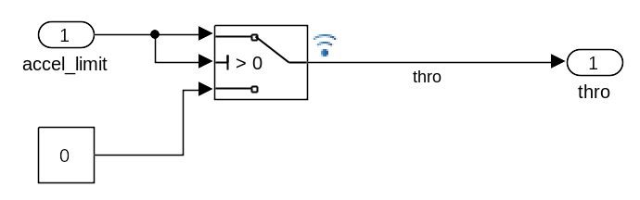

Blocks

Parameters

"accel_limit" (Inport)
표 3-54. "accel_limit" Parameters
Parameter | Value
Port number | 1
Port dimensions (-1 for inherited) | -1
Sample time (-1 for inherited) | -1
Minimum | []
Maximum | []
Data type | Inherit: auto

"Constant" (Constant)
표 3-55. "Constant" Parameters
Parameter | Value
Constant value | 0
Interpret vector parameters as 1-D | on
Output minimum | []
Output maximum | []
Output data type | Inherit: Inherit from 'Constant value'
Lock output data type setting against changes by the fixed-point tools | off
Sample time | inf
Frame period | inf

"Switch1" (Switch)
표 3-56. "Switch1" Parameters
Parameter | Value
Criteria for passing first input | u2 > Threshold
Threshold | 0
Require all data port inputs to have the same data type | off
Output minimum | []
Output maximum | []
Output data type | Inherit: Inherit via internal rule
Lock output data type setting against changes by the fixed-point tools | off
Integer rounding mode | Floor
Saturate on integer overflow | off
Enable zero-crossing detection | on
Sample time (-1 for inherited) | -1
Allow different data input sizes (Results in variable-size output signal) | off

"thro" (Outport)
표 3-57. "thro" Parameters
Parameter | Value
Port number | 1
Icon display | Port number
Minimum | []
Maximum | []
Data type | Inherit: auto
Lock output data type setting against changes by the fixed-point tools | off
Output as nonvirtual bus in parent model | off
Unit (e.g., m, m/s^2, N*m) | inherit
Port dimensions (-1 for inherited) | -1
Variable-size signal | Inherit
Sample time (-1 for inherited) | -1
Ensure outport is virtual | off
Source of initial output value | Dialog
Output when disabled | held
Initial output | []
MustResolveToSignalObject | off
Specify output when source is unconnected | off
Constant value | 0
Interpret vector parameters as 1-D | off

throttle
그림 3-11. Radar_Acc/ACC Classical/throttle
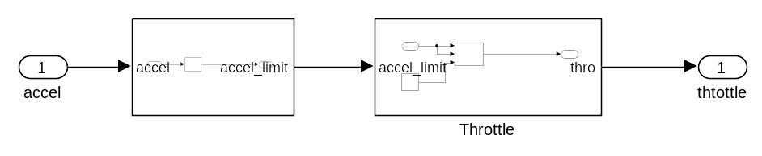

Blocks

Parameters

"accel" (Inport)
표 3-58. "accel" Parameters
Parameter | Value
Port number | 1
Port dimensions (-1 for inherited) | -1
Sample time (-1 for inherited) | -1
Minimum | []
Maximum | []
Data type | Inherit: auto

"thtottle" (Outport)
표 3-59. "thtottle" Parameters
Parameter | Value
Port number | 1
Icon display | Port number
Minimum | []
Maximum | []
Data type | Inherit: auto
Lock output data type setting against changes by the fixed-point tools | off
Output as nonvirtual bus in parent model | off
Unit (e.g., m, m/s^2, N*m) | inherit
Port dimensions (-1 for inherited) | -1
Variable-size signal | Inherit
Sample time (-1 for inherited) | -1
Ensure outport is virtual | off
Source of initial output value | Dialog
Output when disabled | held
Initial output | []
MustResolveToSignalObject | off
Specify output when source is unconnected | off
Constant value | 0
Interpret vector parameters as 1-D | off

4장. System Design Variables

Design Variable Summary
표 4-1. Design Variables
Variable Name | Parent Blocks | Size | Bytes | Class | Value
Ts | Set velocity [36]  Default Spacing [14]  Time Gap [19] | 1x1 | 8 | double | 0.1000
default_spacing | Default Spacing [14] | 1x1 | 8 | double | 100
time_gap | Time Gap [19] | 1x1 | 8 | double | 1.5000
v_set | Set velocity [36] | 1x1 | 8 | double | 95
verr_gain | Gain1 [33] | 1x1 | 8 | double | 0.5000
vx_gain | Gain3 [28] | 1x1 | 8 | double | 0.4000
xerr_gain | Gain2 [28] | 1x1 | 8 | double | 0.2000

Design Variable Details
Ts. 0.1000
Used by Blocks:
• Radar_Acc/ACC Classical/Subsystem/Subsystem2/Set velocity [36]
• Radar_Acc/ACC Classical/Subsystem/comparision:distance/Default Spacing [14]
• Radar_Acc/ACC Classical/Subsystem/comparision:distance/Time Gap [19]
Resolved in: base workspace
default_spacing. 100
Used by Blocks:
• Radar_Acc/ACC Classical/Subsystem/comparision:distance/Default Spacing [14]
Resolved in: base workspace
time_gap. 1.5000
Used by Blocks:
• Radar_Acc/ACC Classical/Subsystem/comparision:distance/Time Gap [19]
Resolved in: base workspace
v_set. 95
Used by Blocks:
• Radar_Acc/ACC Classical/Subsystem/Subsystem2/Set velocity [36]
Resolved in: base workspace
verr_gain. 0.5000
Used by Blocks:
• Radar_Acc/ACC Classical/Subsystem/Subsystem2/Gain1 [33]
Resolved in: base workspace
vx_gain. 0.4000
Used by Blocks:
• Radar_Acc/ACC Classical/Subsystem/Subsystem/Gain3 [28]
Resolved in: base workspace
xerr_gain. 0.2000
Used by Blocks:
• Radar_Acc/ACC Classical/Subsystem/Subsystem/Gain2 [28]
Resolved in: base workspace

5장. Requirements

Model Information for "Radar_Acc"
표 5-1. Radar_Acc Version Information
ModelVersion | 1.7 | ConfigurationManager | N/A
Created | Fri Jul 24 13:32:45 2020 | Creator | SJ
LastModifiedDate | Sun Jul 26 23:00:24 2020 | LastModifiedBy | SJ

Document Summary for "Radar_Acc"
표 5-2. Requirements documents linked in model
ID | Artifact names stored by RMI | Last modified | # links
DOC1 | ../../../SJ/Desktop/data_acc/ACC System Safety Requirements.docx (http://localhost:31415/matlab/feval/rmi.navigate?arguments=[%22linktype_rmi_word%22,%22..%5C%5C..%5C%5C..%5C%5CSJ%5C%5CDesktop%5C%5Cdata_acc%5C%5CACC%20System%20Safety%20Requirements.docx%22,%22%22,%22Radar_Acc%22]) | 26-7월-2020 21:16:13 | 73

.

System - ACC Classical
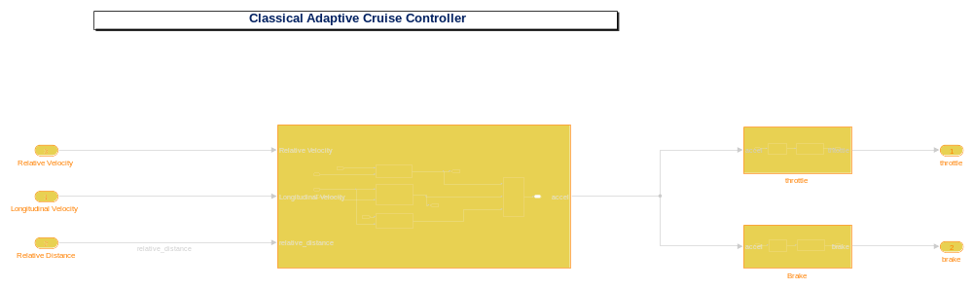
Show in Simulink (http://localhost:31415/matlab/feval/rmiobjnavigate?arguments=[%22Radar_Acc%22,%22:1%22])
표 5-3. Blocks in "ACC Classical" that have requirements
Linked Object | Requirements Data
brake (http://localhost:31415/matlab/feval/rmiobjnavigate?arguments=[%22Radar_Acc%22,%22:25%22]) | 1.  "FSR_00300 잘못된 Brake 값 증가 방지"  ../../../SJ/Desktop/data_acc/ACC System Safety Requirements.docx, at "Simulink_requirement_item_3" (http://localhost:31415/matlab/feval/rmi.navigate?arguments=[%22linktype_rmi_word%22,%22../../../SJ/Desktop/data_acc/ACC%20System%20Safety%20Requirements.docx%22,%22@Simulink_requirement_item_3%22,%22Radar_Acc%22])
Longitudinal Velocity (http://localhost:31415/matlab/feval/rmiobjnavigate?arguments=[%22Radar_Acc%22,%22:2%22]) | 1.  "FSR_00100 속도 변화 작은 값 유지"  ../../../SJ/Desktop/data_acc/ACC System Safety Requirements.docx, at "Simulink_requirement_item_1" (http://localhost:31415/matlab/feval/rmi.navigate?arguments=[%22linktype_rmi_word%22,%22../../../SJ/Desktop/data_acc/ACC%20System%20Safety%20Requirements.docx%22,%22@Simulink_requirement_item_1%22,%22Radar_Acc%22])
Relative Distance (http://localhost:31415/matlab/feval/rmiobjnavigate?arguments=[%22Radar_Acc%22,%22:3%22]) | 1.  "FSR_00100 속도 변화 작은 값 유지"  ../../../SJ/Desktop/data_acc/ACC System Safety Requirements.docx, at "Simulink_requirement_item_1" (http://localhost:31415/matlab/feval/rmi.navigate?arguments=[%22linktype_rmi_word%22,%22../../../SJ/Desktop/data_acc/ACC%20System%20Safety%20Requirements.docx%22,%22@Simulink_requirement_item_1%22,%22Radar_Acc%22])
Relative Velocity (http://localhost:31415/matlab/feval/rmiobjnavigate?arguments=[%22Radar_Acc%22,%22:38%22]) | 1.  "FSR_00100 속도 변화 작은 값 유지"  ../../../SJ/Desktop/data_acc/ACC System Safety Requirements.docx, at "Simulink_requirement_item_1" (http://localhost:31415/matlab/feval/rmi.navigate?arguments=[%22linktype_rmi_word%22,%22../../../SJ/Desktop/data_acc/ACC%20System%20Safety%20Requirements.docx%22,%22@Simulink_requirement_item_1%22,%22Radar_Acc%22])
throttle (http://localhost:31415/matlab/feval/rmiobjnavigate?arguments=[%22Radar_Acc%22,%22:24%22]) | 1.  "FSR_00200 잘못된throttle값 증가 방지"  ../../../SJ/Desktop/data_acc/ACC System Safety Requirements.docx, at "Simulink_requirement_item_2" (http://localhost:31415/matlab/feval/rmi.navigate?arguments=[%22linktype_rmi_word%22,%22../../../SJ/Desktop/data_acc/ACC%20System%20Safety%20Requirements.docx%22,%22@Simulink_requirement_item_2%22,%22Radar_Acc%22])

.

System - Brake
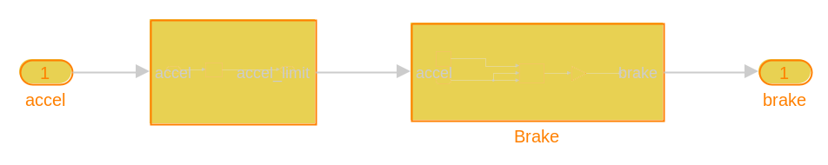
Show in Simulink (http://localhost:31415/matlab/feval/rmiobjnavigate?arguments=[%22Radar_Acc%22,%22:95%22])
표 5-4. Radar_Acc/ACC Classical/Brake Requirements
Link# | Link Description | Link Target (document name and location ID)
1. | "FSR_00300 잘못된 Brake 값 증가 방지" | ../../../SJ/Desktop/data_acc/ACC System Safety Requirements.docx, at "Simulink_requirement_item_3" (http://localhost:31415/matlab/feval/rmi.navigate?arguments=[%22linktype_rmi_word%22,%22../../../SJ/Desktop/data_acc/ACC%20System%20Safety%20Requirements.docx%22,%22@Simulink_requirement_item_3%22,%22Radar_Acc%22])

표 5-5. Blocks in "Brake" that have requirements
Linked Object | Requirements Data
accel (http://localhost:31415/matlab/feval/rmiobjnavigate?arguments=[%22Radar_Acc%22,%22:96%22]) | 1.  "TSR_00600 속도감소"  ../../../SJ/Desktop/data_acc/ACC System Safety Requirements.docx, at "Simulink_requirement_item_20" (http://localhost:31415/matlab/feval/rmi.navigate?arguments=[%22linktype_rmi_word%22,%22../../../SJ/Desktop/data_acc/ACC%20System%20Safety%20Requirements.docx%22,%22@Simulink_requirement_item_20%22,%22Radar_Acc%22])
brake (http://localhost:31415/matlab/feval/rmiobjnavigate?arguments=[%22Radar_Acc%22,%22:97%22]) | 1.  "TSR_00600 속도감소"  ../../../SJ/Desktop/data_acc/ACC System Safety Requirements.docx, at "Simulink_requirement_item_20" (http://localhost:31415/matlab/feval/rmi.navigate?arguments=[%22linktype_rmi_word%22,%22../../../SJ/Desktop/data_acc/ACC%20System%20Safety%20Requirements.docx%22,%22@Simulink_requirement_item_20%22,%22Radar_Acc%22])

.

System - Subsystem
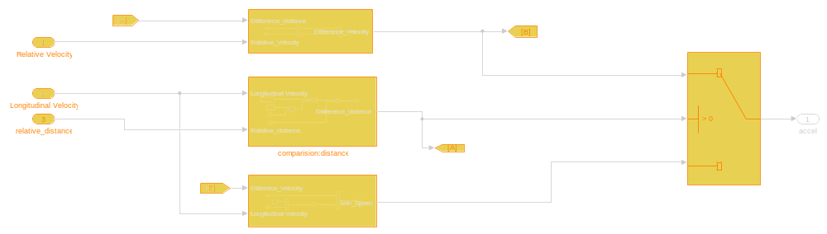
Show in Simulink (http://localhost:31415/matlab/feval/rmiobjnavigate?arguments=[%22Radar_Acc%22,%22:98%22])
표 5-6. Radar_Acc/ACC Classical/Subsystem Requirements
Link# | Link Description | Link Target (document name and location ID)
1. | "FSR_00100 속도 변화 작은 값 유지" | ../../../SJ/Desktop/data_acc/ACC System Safety Requirements.docx, at "Simulink_requirement_item_1" (http://localhost:31415/matlab/feval/rmi.navigate?arguments=[%22linktype_rmi_word%22,%22../../../SJ/Desktop/data_acc/ACC%20System%20Safety%20Requirements.docx%22,%22@Simulink_requirement_item_1%22,%22Radar_Acc%22])

표 5-7. Blocks in "Subsystem" that have requirements
Linked Object | Requirements Data
From (http://localhost:31415/matlab/feval/rmiobjnavigate?arguments=[%22Radar_Acc%22,%22:27%22]) | 1.  "TSR_00200 안전범위 내"  ../../../SJ/Desktop/data_acc/ACC System Safety Requirements.docx, at "Simulink_requirement_item_5" (http://localhost:31415/matlab/feval/rmi.navigate?arguments=[%22linktype_rmi_word%22,%22../../../SJ/Desktop/data_acc/ACC%20System%20Safety%20Requirements.docx%22,%22@Simulink_requirement_item_5%22,%22Radar_Acc%22])  2.  "TSR_00300 안전범위 외"  ../../../SJ/Desktop/data_acc/ACC System Safety Requirements.docx, at "Simulink_requirement_item_6" (http://localhost:31415/matlab/feval/rmi.navigate?arguments=[%22linktype_rmi_word%22,%22../../../SJ/Desktop/data_acc/ACC%20System%20Safety%20Requirements.docx%22,%22@Simulink_requirement_item_6%22,%22Radar_Acc%22])
From1 (http://localhost:31415/matlab/feval/rmiobjnavigate?arguments=[%22Radar_Acc%22,%22:69%22]) | 1.  "TSR_00300 안전범위 외"  ../../../SJ/Desktop/data_acc/ACC System Safety Requirements.docx, at "Simulink_requirement_item_6" (http://localhost:31415/matlab/feval/rmi.navigate?arguments=[%22linktype_rmi_word%22,%22../../../SJ/Desktop/data_acc/ACC%20System%20Safety%20Requirements.docx%22,%22@Simulink_requirement_item_6%22,%22Radar_Acc%22])
Goto (http://localhost:31415/matlab/feval/rmiobjnavigate?arguments=[%22Radar_Acc%22,%22:28%22]) | 1.  "TSR_00100 거리비교"  ../../../SJ/Desktop/data_acc/ACC System Safety Requirements.docx, at "Simulink_requirement_item_4" (http://localhost:31415/matlab/feval/rmi.navigate?arguments=[%22linktype_rmi_word%22,%22../../../SJ/Desktop/data_acc/ACC%20System%20Safety%20Requirements.docx%22,%22@Simulink_requirement_item_4%22,%22Radar_Acc%22])
Goto1 (http://localhost:31415/matlab/feval/rmiobjnavigate?arguments=[%22Radar_Acc%22,%22:70%22]) | 1.  "TSR_00200 안전범위 내"  ../../../SJ/Desktop/data_acc/ACC System Safety Requirements.docx, at "Simulink_requirement_item_5" (http://localhost:31415/matlab/feval/rmi.navigate?arguments=[%22linktype_rmi_word%22,%22../../../SJ/Desktop/data_acc/ACC%20System%20Safety%20Requirements.docx%22,%22@Simulink_requirement_item_5%22,%22Radar_Acc%22])  2.  "TSR_00300 안전범위 외"  ../../../SJ/Desktop/data_acc/ACC System Safety Requirements.docx, at "Simulink_requirement_item_6" (http://localhost:31415/matlab/feval/rmi.navigate?arguments=[%22linktype_rmi_word%22,%22../../../SJ/Desktop/data_acc/ACC%20System%20Safety%20Requirements.docx%22,%22@Simulink_requirement_item_6%22,%22Radar_Acc%22])
Longitudinal Velocity (http://localhost:31415/matlab/feval/rmiobjnavigate?arguments=[%22Radar_Acc%22,%22:100%22]) | 1.  "TSR_00100 거리비교"  ../../../SJ/Desktop/data_acc/ACC System Safety Requirements.docx, at "Simulink_requirement_item_4" (http://localhost:31415/matlab/feval/rmi.navigate?arguments=[%22linktype_rmi_word%22,%22../../../SJ/Desktop/data_acc/ACC%20System%20Safety%20Requirements.docx%22,%22@Simulink_requirement_item_4%22,%22Radar_Acc%22])
Relative Velocity (http://localhost:31415/matlab/feval/rmiobjnavigate?arguments=[%22Radar_Acc%22,%22:99%22]) | 1.  "TSR_00200 안전범위 내"  ../../../SJ/Desktop/data_acc/ACC System Safety Requirements.docx, at "Simulink_requirement_item_5" (http://localhost:31415/matlab/feval/rmi.navigate?arguments=[%22linktype_rmi_word%22,%22../../../SJ/Desktop/data_acc/ACC%20System%20Safety%20Requirements.docx%22,%22@Simulink_requirement_item_5%22,%22Radar_Acc%22])  2.  "TSR_00300 안전범위 외"  ../../../SJ/Desktop/data_acc/ACC System Safety Requirements.docx, at "Simulink_requirement_item_6" (http://localhost:31415/matlab/feval/rmi.navigate?arguments=[%22linktype_rmi_word%22,%22../../../SJ/Desktop/data_acc/ACC%20System%20Safety%20Requirements.docx%22,%22@Simulink_requirement_item_6%22,%22Radar_Acc%22])
relative_distance (http://localhost:31415/matlab/feval/rmiobjnavigate?arguments=[%22Radar_Acc%22,%22:101%22]) | 1.  "TSR_00100 거리비교"  ../../../SJ/Desktop/data_acc/ACC System Safety Requirements.docx, at "Simulink_requirement_item_4" (http://localhost:31415/matlab/feval/rmi.navigate?arguments=[%22linktype_rmi_word%22,%22../../../SJ/Desktop/data_acc/ACC%20System%20Safety%20Requirements.docx%22,%22@Simulink_requirement_item_4%22,%22Radar_Acc%22])
Switch (http://localhost:31415/matlab/feval/rmiobjnavigate?arguments=[%22Radar_Acc%22,%22:20%22]) | 1.  "TSR_00300 안전범위 외"  ../../../SJ/Desktop/data_acc/ACC System Safety Requirements.docx, at "Simulink_requirement_item_6" (http://localhost:31415/matlab/feval/rmi.navigate?arguments=[%22linktype_rmi_word%22,%22../../../SJ/Desktop/data_acc/ACC%20System%20Safety%20Requirements.docx%22,%22@Simulink_requirement_item_6%22,%22Radar_Acc%22])  2.  "TSR_00200 안전범위 내"  ../../../SJ/Desktop/data_acc/ACC System Safety Requirements.docx, at "Simulink_requirement_item_5" (http://localhost:31415/matlab/feval/rmi.navigate?arguments=[%22linktype_rmi_word%22,%22../../../SJ/Desktop/data_acc/ACC%20System%20Safety%20Requirements.docx%22,%22@Simulink_requirement_item_5%22,%22Radar_Acc%22])  3.  "TSR_00100 거리비교"  ../../../SJ/Desktop/data_acc/ACC System Safety Requirements.docx, at "Simulink_requirement_item_4" (http://localhost:31415/matlab/feval/rmi.navigate?arguments=[%22linktype_rmi_word%22,%22../../../SJ/Desktop/data_acc/ACC%20System%20Safety%20Requirements.docx%22,%22@Simulink_requirement_item_4%22,%22Radar_Acc%22])

.

System - throttle
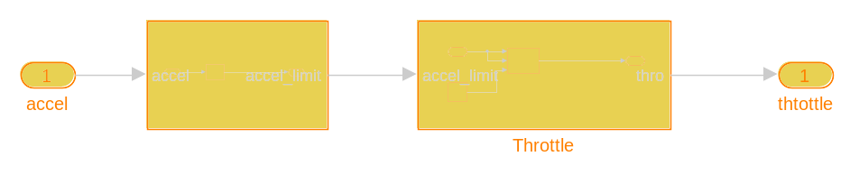
Show in Simulink (http://localhost:31415/matlab/feval/rmiobjnavigate?arguments=[%22Radar_Acc%22,%22:92%22])
표 5-8. Radar_Acc/ACC Classical/throttle Requirements
Link# | Link Description | Link Target (document name and location ID)
1. | "FSR_00200 잘못된throttle값 증가 방지" | ../../../SJ/Desktop/data_acc/ACC System Safety Requirements.docx, at "Simulink_requirement_item_2" (http://localhost:31415/matlab/feval/rmi.navigate?arguments=[%22linktype_rmi_word%22,%22../../../SJ/Desktop/data_acc/ACC%20System%20Safety%20Requirements.docx%22,%22@Simulink_requirement_item_2%22,%22Radar_Acc%22])

표 5-9. Blocks in "throttle " that have requirements
Linked Object | Requirements Data
accel (http://localhost:31415/matlab/feval/rmiobjnavigate?arguments=[%22Radar_Acc%22,%22:93%22]) | 1.  "TSR_00400 속도증가"  ../../../SJ/Desktop/data_acc/ACC System Safety Requirements.docx, at "Simulink_requirement_item_15" (http://localhost:31415/matlab/feval/rmi.navigate?arguments=[%22linktype_rmi_word%22,%22../../../SJ/Desktop/data_acc/ACC%20System%20Safety%20Requirements.docx%22,%22@Simulink_requirement_item_15%22,%22Radar_Acc%22])
thtottle (http://localhost:31415/matlab/feval/rmiobjnavigate?arguments=[%22Radar_Acc%22,%22:94%22]) | 1.  "TSR_00400 속도증가"  ../../../SJ/Desktop/data_acc/ACC System Safety Requirements.docx, at "Simulink_requirement_item_15" (http://localhost:31415/matlab/feval/rmi.navigate?arguments=[%22linktype_rmi_word%22,%22../../../SJ/Desktop/data_acc/ACC%20System%20Safety%20Requirements.docx%22,%22@Simulink_requirement_item_15%22,%22Radar_Acc%22])

.

System - Brake
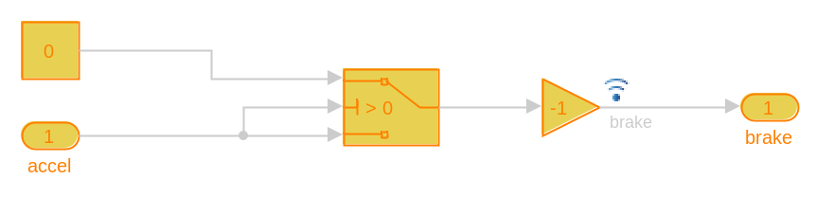
Show in Simulink (http://localhost:31415/matlab/feval/rmiobjnavigate?arguments=[%22Radar_Acc%22,%22:33%22])
표 5-10. Radar_Acc/ACC Classical/Brake/Brake Requirements
Link# | Link Description | Link Target (document name and location ID)
1. | "TSR_00600 속도감소" | ../../../SJ/Desktop/data_acc/ACC System Safety Requirements.docx, at "Simulink_requirement_item_20" (http://localhost:31415/matlab/feval/rmi.navigate?arguments=[%22linktype_rmi_word%22,%22../../../SJ/Desktop/data_acc/ACC%20System%20Safety%20Requirements.docx%22,%22@Simulink_requirement_item_20%22,%22Radar_Acc%22])

표 5-11. Blocks in "Brake" that have requirements
Linked Object | Requirements Data
accel (http://localhost:31415/matlab/feval/rmiobjnavigate?arguments=[%22Radar_Acc%22,%22:34%22]) | 1.  "SSR_010601 Brake"  ../../../SJ/Desktop/data_acc/ACC System Safety Requirements.docx, at "Simulink_requirement_item_23" (http://localhost:31415/matlab/feval/rmi.navigate?arguments=[%22linktype_rmi_word%22,%22../../../SJ/Desktop/data_acc/ACC%20System%20Safety%20Requirements.docx%22,%22@Simulink_requirement_item_23%22,%22Radar_Acc%22])
brake (http://localhost:31415/matlab/feval/rmiobjnavigate?arguments=[%22Radar_Acc%22,%22:35%22]) | 1.  "SSR_010502 Output:Brake"  ../../../SJ/Desktop/data_acc/ACC System Safety Requirements.docx, at "Simulink_requirement_item_24" (http://localhost:31415/matlab/feval/rmi.navigate?arguments=[%22linktype_rmi_word%22,%22../../../SJ/Desktop/data_acc/ACC%20System%20Safety%20Requirements.docx%22,%22@Simulink_requirement_item_24%22,%22Radar_Acc%22])
Constant1 (http://localhost:31415/matlab/feval/rmiobjnavigate?arguments=[%22Radar_Acc%22,%22:6%22]) | 1.  "SSR_010601 Brake"  ../../../SJ/Desktop/data_acc/ACC System Safety Requirements.docx, at "Simulink_requirement_item_23" (http://localhost:31415/matlab/feval/rmi.navigate?arguments=[%22linktype_rmi_word%22,%22../../../SJ/Desktop/data_acc/ACC%20System%20Safety%20Requirements.docx%22,%22@Simulink_requirement_item_23%22,%22Radar_Acc%22])
Gain (http://localhost:31415/matlab/feval/rmiobjnavigate?arguments=[%22Radar_Acc%22,%22:8%22]) | 1.  "SSR_010601 Brake"  ../../../SJ/Desktop/data_acc/ACC System Safety Requirements.docx, at "Simulink_requirement_item_23" (http://localhost:31415/matlab/feval/rmi.navigate?arguments=[%22linktype_rmi_word%22,%22../../../SJ/Desktop/data_acc/ACC%20System%20Safety%20Requirements.docx%22,%22@Simulink_requirement_item_23%22,%22Radar_Acc%22])
Switch2 (http://localhost:31415/matlab/feval/rmiobjnavigate?arguments=[%22Radar_Acc%22,%22:22%22]) | 1.  "SSR_010601 Brake"  ../../../SJ/Desktop/data_acc/ACC System Safety Requirements.docx, at "Simulink_requirement_item_23" (http://localhost:31415/matlab/feval/rmi.navigate?arguments=[%22linktype_rmi_word%22,%22../../../SJ/Desktop/data_acc/ACC%20System%20Safety%20Requirements.docx%22,%22@Simulink_requirement_item_23%22,%22Radar_Acc%22])

.

System - Subsystem
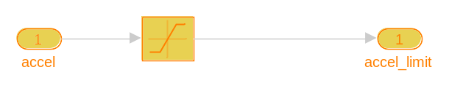
Show in Simulink (http://localhost:31415/matlab/feval/rmiobjnavigate?arguments=[%22Radar_Acc%22,%22:107%22])
표 5-12. Radar_Acc/ACC Classical/Brake/Subsystem Requirements
Link# | Link Description | Link Target (document name and location ID)
1. | "TSR_00700 Brake 값의 급격한 증가 방지" | ../../../SJ/Desktop/data_acc/ACC System Safety Requirements.docx, at "Simulink_requirement_item_21" (http://localhost:31415/matlab/feval/rmi.navigate?arguments=[%22linktype_rmi_word%22,%22../../../SJ/Desktop/data_acc/ACC%20System%20Safety%20Requirements.docx%22,%22@Simulink_requirement_item_21%22,%22Radar_Acc%22])

표 5-13. Blocks in "Subsystem" that have requirements
Linked Object | Requirements Data
accel (http://localhost:31415/matlab/feval/rmiobjnavigate?arguments=[%22Radar_Acc%22,%22:108%22]) | 1.  "SSR_010701 Saturation:Brake"  ../../../SJ/Desktop/data_acc/ACC System Safety Requirements.docx, at "Simulink_requirement_item_22" (http://localhost:31415/matlab/feval/rmi.navigate?arguments=[%22linktype_rmi_word%22,%22../../../SJ/Desktop/data_acc/ACC%20System%20Safety%20Requirements.docx%22,%22@Simulink_requirement_item_22%22,%22Radar_Acc%22])
accel_limit (http://localhost:31415/matlab/feval/rmiobjnavigate?arguments=[%22Radar_Acc%22,%22:109%22]) | 1.  "SSR_010701 Saturation:Brake"  ../../../SJ/Desktop/data_acc/ACC System Safety Requirements.docx, at "Simulink_requirement_item_22" (http://localhost:31415/matlab/feval/rmi.navigate?arguments=[%22linktype_rmi_word%22,%22../../../SJ/Desktop/data_acc/ACC%20System%20Safety%20Requirements.docx%22,%22@Simulink_requirement_item_22%22,%22Radar_Acc%22])
Saturation1 (http://localhost:31415/matlab/feval/rmiobjnavigate?arguments=[%22Radar_Acc%22,%22:91%22]) | 1.  "SSR_010701 Saturation:Brake"  ../../../SJ/Desktop/data_acc/ACC System Safety Requirements.docx, at "Simulink_requirement_item_22" (http://localhost:31415/matlab/feval/rmi.navigate?arguments=[%22linktype_rmi_word%22,%22../../../SJ/Desktop/data_acc/ACC%20System%20Safety%20Requirements.docx%22,%22@Simulink_requirement_item_22%22,%22Radar_Acc%22])

.

System - Subsystem
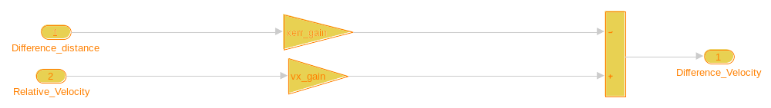
Show in Simulink (http://localhost:31415/matlab/feval/rmiobjnavigate?arguments=[%22Radar_Acc%22,%22:41%22])
표 5-14. Radar_Acc/ACC Classical/Subsystem/Subsystem Requirements
Link# | Link Description | Link Target (document name and location ID)
1. | "TSR_00200 안전범위 내" | ../../../SJ/Desktop/data_acc/ACC System Safety Requirements.docx, at "Simulink_requirement_item_5" (http://localhost:31415/matlab/feval/rmi.navigate?arguments=[%22linktype_rmi_word%22,%22../../../SJ/Desktop/data_acc/ACC%20System%20Safety%20Requirements.docx%22,%22@Simulink_requirement_item_5%22,%22Radar_Acc%22])
2. | "TSR_00300 안전범위 외" | ../../../SJ/Desktop/data_acc/ACC System Safety Requirements.docx, at "Simulink_requirement_item_6" (http://localhost:31415/matlab/feval/rmi.navigate?arguments=[%22linktype_rmi_word%22,%22../../../SJ/Desktop/data_acc/ACC%20System%20Safety%20Requirements.docx%22,%22@Simulink_requirement_item_6%22,%22Radar_Acc%22])

표 5-15. Blocks in "Subsystem" that have requirements
Linked Object | Requirements Data
Difference_distance (http://localhost:31415/matlab/feval/rmiobjnavigate?arguments=[%22Radar_Acc%22,%22:42%22]) | 1.  "SSR_010201 Input:difference"  ../../../SJ/Desktop/data_acc/ACC System Safety Requirements.docx, at "Simulink_requirement_item_10" (http://localhost:31415/matlab/feval/rmi.navigate?arguments=[%22linktype_rmi_word%22,%22../../../SJ/Desktop/data_acc/ACC%20System%20Safety%20Requirements.docx%22,%22@Simulink_requirement_item_10%22,%22Radar_Acc%22])
Difference_Velocity (http://localhost:31415/matlab/feval/rmiobjnavigate?arguments=[%22Radar_Acc%22,%22:44%22]) | 1.  "SSR_010202 Compute:distance"  ../../../SJ/Desktop/data_acc/ACC System Safety Requirements.docx, at "Simulink_requirement_item_11" (http://localhost:31415/matlab/feval/rmi.navigate?arguments=[%22linktype_rmi_word%22,%22../../../SJ/Desktop/data_acc/ACC%20System%20Safety%20Requirements.docx%22,%22@Simulink_requirement_item_11%22,%22Radar_Acc%22])  2.  "SSR_010302 Compute:difference"  ../../../SJ/Desktop/data_acc/ACC System Safety Requirements.docx, at "Simulink_requirement_item_13" (http://localhost:31415/matlab/feval/rmi.navigate?arguments=[%22linktype_rmi_word%22,%22../../../SJ/Desktop/data_acc/ACC%20System%20Safety%20Requirements.docx%22,%22@Simulink_requirement_item_13%22,%22Radar_Acc%22])
Gain2 (http://localhost:31415/matlab/feval/rmiobjnavigate?arguments=[%22Radar_Acc%22,%22:10%22]) | 1.  "SSR_010202 Compute:distance"  ../../../SJ/Desktop/data_acc/ACC System Safety Requirements.docx, at "Simulink_requirement_item_11" (http://localhost:31415/matlab/feval/rmi.navigate?arguments=[%22linktype_rmi_word%22,%22../../../SJ/Desktop/data_acc/ACC%20System%20Safety%20Requirements.docx%22,%22@Simulink_requirement_item_11%22,%22Radar_Acc%22])  2.  "SSR_010302 Compute:difference"  ../../../SJ/Desktop/data_acc/ACC System Safety Requirements.docx, at "Simulink_requirement_item_13" (http://localhost:31415/matlab/feval/rmi.navigate?arguments=[%22linktype_rmi_word%22,%22../../../SJ/Desktop/data_acc/ACC%20System%20Safety%20Requirements.docx%22,%22@Simulink_requirement_item_13%22,%22Radar_Acc%22])
Gain3 (http://localhost:31415/matlab/feval/rmiobjnavigate?arguments=[%22Radar_Acc%22,%22:11%22]) | 1.  "SSR_010202 Compute:distance"  ../../../SJ/Desktop/data_acc/ACC System Safety Requirements.docx, at "Simulink_requirement_item_11" (http://localhost:31415/matlab/feval/rmi.navigate?arguments=[%22linktype_rmi_word%22,%22../../../SJ/Desktop/data_acc/ACC%20System%20Safety%20Requirements.docx%22,%22@Simulink_requirement_item_11%22,%22Radar_Acc%22])  2.  "SSR_010302 Compute:difference"  ../../../SJ/Desktop/data_acc/ACC System Safety Requirements.docx, at "Simulink_requirement_item_13" (http://localhost:31415/matlab/feval/rmi.navigate?arguments=[%22linktype_rmi_word%22,%22../../../SJ/Desktop/data_acc/ACC%20System%20Safety%20Requirements.docx%22,%22@Simulink_requirement_item_13%22,%22Radar_Acc%22])
Relative_Velocity (http://localhost:31415/matlab/feval/rmiobjnavigate?arguments=[%22Radar_Acc%22,%22:43%22]) | 1.  "SSR_010201 Input:difference"  ../../../SJ/Desktop/data_acc/ACC System Safety Requirements.docx, at "Simulink_requirement_item_10" (http://localhost:31415/matlab/feval/rmi.navigate?arguments=[%22linktype_rmi_word%22,%22../../../SJ/Desktop/data_acc/ACC%20System%20Safety%20Requirements.docx%22,%22@Simulink_requirement_item_10%22,%22Radar_Acc%22])
Sum3 (http://localhost:31415/matlab/feval/rmiobjnavigate?arguments=[%22Radar_Acc%22,%22:18%22]) | 1.  "SSR_010202 Compute:distance"  ../../../SJ/Desktop/data_acc/ACC System Safety Requirements.docx, at "Simulink_requirement_item_11" (http://localhost:31415/matlab/feval/rmi.navigate?arguments=[%22linktype_rmi_word%22,%22../../../SJ/Desktop/data_acc/ACC%20System%20Safety%20Requirements.docx%22,%22@Simulink_requirement_item_11%22,%22Radar_Acc%22])  2.  "SSR_010302 Compute:difference"  ../../../SJ/Desktop/data_acc/ACC System Safety Requirements.docx, at "Simulink_requirement_item_13" (http://localhost:31415/matlab/feval/rmi.navigate?arguments=[%22linktype_rmi_word%22,%22../../../SJ/Desktop/data_acc/ACC%20System%20Safety%20Requirements.docx%22,%22@Simulink_requirement_item_13%22,%22Radar_Acc%22])

.

System - Subsystem2
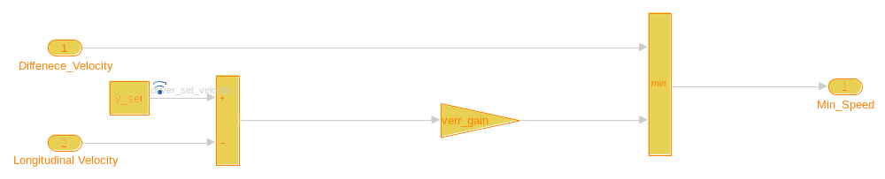
Show in Simulink (http://localhost:31415/matlab/feval/rmiobjnavigate?arguments=[%22Radar_Acc%22,%22:64%22])
표 5-16. Radar_Acc/ACC Classical/Subsystem/Subsystem2 Requirements
Link# | Link Description | Link Target (document name and location ID)
1. | "TSR_00300 안전범위 외" | ../../../SJ/Desktop/data_acc/ACC System Safety Requirements.docx, at "Simulink_requirement_item_6" (http://localhost:31415/matlab/feval/rmi.navigate?arguments=[%22linktype_rmi_word%22,%22../../../SJ/Desktop/data_acc/ACC%20System%20Safety%20Requirements.docx%22,%22@Simulink_requirement_item_6%22,%22Radar_Acc%22])

표 5-17. Blocks in "Subsystem2" that have requirements
Linked Object | Requirements Data
Diffenece_Velocity (http://localhost:31415/matlab/feval/rmiobjnavigate?arguments=[%22Radar_Acc%22,%22:65%22]) | 1.  "SSR_010302 Compute:difference"  ../../../SJ/Desktop/data_acc/ACC System Safety Requirements.docx, at "Simulink_requirement_item_13" (http://localhost:31415/matlab/feval/rmi.navigate?arguments=[%22linktype_rmi_word%22,%22../../../SJ/Desktop/data_acc/ACC%20System%20Safety%20Requirements.docx%22,%22@Simulink_requirement_item_13%22,%22Radar_Acc%22])
Gain1 (http://localhost:31415/matlab/feval/rmiobjnavigate?arguments=[%22Radar_Acc%22,%22:9%22]) | 1.  "SSR_010301 Compute:V_set"  ../../../SJ/Desktop/data_acc/ACC System Safety Requirements.docx, at "Simulink_requirement_item_12" (http://localhost:31415/matlab/feval/rmi.navigate?arguments=[%22linktype_rmi_word%22,%22../../../SJ/Desktop/data_acc/ACC%20System%20Safety%20Requirements.docx%22,%22@Simulink_requirement_item_12%22,%22Radar_Acc%22])
Longitudinal Velocity (http://localhost:31415/matlab/feval/rmiobjnavigate?arguments=[%22Radar_Acc%22,%22:66%22]) | 1.  "SSR_010301 Compute:V_set"  ../../../SJ/Desktop/data_acc/ACC System Safety Requirements.docx, at "Simulink_requirement_item_12" (http://localhost:31415/matlab/feval/rmi.navigate?arguments=[%22linktype_rmi_word%22,%22../../../SJ/Desktop/data_acc/ACC%20System%20Safety%20Requirements.docx%22,%22@Simulink_requirement_item_12%22,%22Radar_Acc%22])
Min (http://localhost:31415/matlab/feval/rmiobjnavigate?arguments=[%22Radar_Acc%22,%22:12%22]) | 1.  "SSR_01033 Comparision:speed"  ../../../SJ/Desktop/data_acc/ACC System Safety Requirements.docx, at "Simulink_requirement_item_14" (http://localhost:31415/matlab/feval/rmi.navigate?arguments=[%22linktype_rmi_word%22,%22../../../SJ/Desktop/data_acc/ACC%20System%20Safety%20Requirements.docx%22,%22@Simulink_requirement_item_14%22,%22Radar_Acc%22])
Min_Speed (http://localhost:31415/matlab/feval/rmiobjnavigate?arguments=[%22Radar_Acc%22,%22:67%22]) | 1.  "SSR_01033 Comparision:speed"  ../../../SJ/Desktop/data_acc/ACC System Safety Requirements.docx, at "Simulink_requirement_item_14" (http://localhost:31415/matlab/feval/rmi.navigate?arguments=[%22linktype_rmi_word%22,%22../../../SJ/Desktop/data_acc/ACC%20System%20Safety%20Requirements.docx%22,%22@Simulink_requirement_item_14%22,%22Radar_Acc%22])
Set velocity (http://localhost:31415/matlab/feval/rmiobjnavigate?arguments=[%22Radar_Acc%22,%22:15%22]) | 1.  "SSR_010301 Compute:V_set"  ../../../SJ/Desktop/data_acc/ACC System Safety Requirements.docx, at "Simulink_requirement_item_12" (http://localhost:31415/matlab/feval/rmi.navigate?arguments=[%22linktype_rmi_word%22,%22../../../SJ/Desktop/data_acc/ACC%20System%20Safety%20Requirements.docx%22,%22@Simulink_requirement_item_12%22,%22Radar_Acc%22])
Sum4 (http://localhost:31415/matlab/feval/rmiobjnavigate?arguments=[%22Radar_Acc%22,%22:19%22]) | 1.  "SSR_010301 Compute:V_set"  ../../../SJ/Desktop/data_acc/ACC System Safety Requirements.docx, at "Simulink_requirement_item_12" (http://localhost:31415/matlab/feval/rmi.navigate?arguments=[%22linktype_rmi_word%22,%22../../../SJ/Desktop/data_acc/ACC%20System%20Safety%20Requirements.docx%22,%22@Simulink_requirement_item_12%22,%22Radar_Acc%22])

.

System - comparision:distance
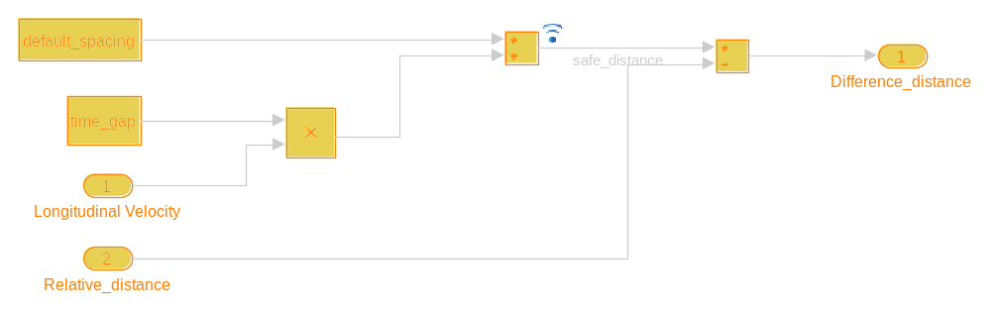
Show in Simulink (http://localhost:31415/matlab/feval/rmiobjnavigate?arguments=[%22Radar_Acc%22,%22:60%22])
표 5-18. Radar_Acc/ACC Classical/Subsystem/comparision:distance Requirements
Link# | Link Description | Link Target (document name and location ID)
1. | "TSR_00100 거리비교" | ../../../SJ/Desktop/data_acc/ACC System Safety Requirements.docx, at "Simulink_requirement_item_4" (http://localhost:31415/matlab/feval/rmi.navigate?arguments=[%22linktype_rmi_word%22,%22../../../SJ/Desktop/data_acc/ACC%20System%20Safety%20Requirements.docx%22,%22@Simulink_requirement_item_4%22,%22Radar_Acc%22])

표 5-19. Blocks in "comparision:distance" that have requirements
Linked Object | Requirements Data
Default Spacing (http://localhost:31415/matlab/feval/rmiobjnavigate?arguments=[%22Radar_Acc%22,%22:7%22]) | 1.  "SSR_010102 Safe distance"  ../../../SJ/Desktop/data_acc/ACC System Safety Requirements.docx, at "Simulink_requirement_item_8" (http://localhost:31415/matlab/feval/rmi.navigate?arguments=[%22linktype_rmi_word%22,%22../../../SJ/Desktop/data_acc/ACC%20System%20Safety%20Requirements.docx%22,%22@Simulink_requirement_item_8%22,%22Radar_Acc%22])
Difference_distance (http://localhost:31415/matlab/feval/rmiobjnavigate?arguments=[%22Radar_Acc%22,%22:63%22]) | 1.  "SSR_010103 Comparsion:distance"  ../../../SJ/Desktop/data_acc/ACC System Safety Requirements.docx, at "Simulink_requirement_item_9" (http://localhost:31415/matlab/feval/rmi.navigate?arguments=[%22linktype_rmi_word%22,%22../../../SJ/Desktop/data_acc/ACC%20System%20Safety%20Requirements.docx%22,%22@Simulink_requirement_item_9%22,%22Radar_Acc%22])
Longitudinal Velocity (http://localhost:31415/matlab/feval/rmiobjnavigate?arguments=[%22Radar_Acc%22,%22:61%22]) | 1.  "SSR_010101 Input:Dsafe"  ../../../SJ/Desktop/data_acc/ACC System Safety Requirements.docx, at "Simulink_requirement_item_7" (http://localhost:31415/matlab/feval/rmi.navigate?arguments=[%22linktype_rmi_word%22,%22../../../SJ/Desktop/data_acc/ACC%20System%20Safety%20Requirements.docx%22,%22@Simulink_requirement_item_7%22,%22Radar_Acc%22])
Product (http://localhost:31415/matlab/feval/rmiobjnavigate?arguments=[%22Radar_Acc%22,%22:13%22]) | 1.  "SSR_010102 Safe distance"  ../../../SJ/Desktop/data_acc/ACC System Safety Requirements.docx, at "Simulink_requirement_item_8" (http://localhost:31415/matlab/feval/rmi.navigate?arguments=[%22linktype_rmi_word%22,%22../../../SJ/Desktop/data_acc/ACC%20System%20Safety%20Requirements.docx%22,%22@Simulink_requirement_item_8%22,%22Radar_Acc%22])
Relative_distance (http://localhost:31415/matlab/feval/rmiobjnavigate?arguments=[%22Radar_Acc%22,%22:62%22]) | 1.  "SSR_010101 Input:Dsafe"  ../../../SJ/Desktop/data_acc/ACC System Safety Requirements.docx, at "Simulink_requirement_item_7" (http://localhost:31415/matlab/feval/rmi.navigate?arguments=[%22linktype_rmi_word%22,%22../../../SJ/Desktop/data_acc/ACC%20System%20Safety%20Requirements.docx%22,%22@Simulink_requirement_item_7%22,%22Radar_Acc%22])
Sum1 (http://localhost:31415/matlab/feval/rmiobjnavigate?arguments=[%22Radar_Acc%22,%22:16%22]) | 1.  "SSR_010103 Comparsion:distance"  ../../../SJ/Desktop/data_acc/ACC System Safety Requirements.docx, at "Simulink_requirement_item_9" (http://localhost:31415/matlab/feval/rmi.navigate?arguments=[%22linktype_rmi_word%22,%22../../../SJ/Desktop/data_acc/ACC%20System%20Safety%20Requirements.docx%22,%22@Simulink_requirement_item_9%22,%22Radar_Acc%22])
Sum2 (http://localhost:31415/matlab/feval/rmiobjnavigate?arguments=[%22Radar_Acc%22,%22:17%22]) | 1.  "SSR_010102 Safe distance"  ../../../SJ/Desktop/data_acc/ACC System Safety Requirements.docx, at "Simulink_requirement_item_8" (http://localhost:31415/matlab/feval/rmi.navigate?arguments=[%22linktype_rmi_word%22,%22../../../SJ/Desktop/data_acc/ACC%20System%20Safety%20Requirements.docx%22,%22@Simulink_requirement_item_8%22,%22Radar_Acc%22])
Time Gap (http://localhost:31415/matlab/feval/rmiobjnavigate?arguments=[%22Radar_Acc%22,%22:23%22]) | 1.  "SSR_010102 Safe distance"  ../../../SJ/Desktop/data_acc/ACC System Safety Requirements.docx, at "Simulink_requirement_item_8" (http://localhost:31415/matlab/feval/rmi.navigate?arguments=[%22linktype_rmi_word%22,%22../../../SJ/Desktop/data_acc/ACC%20System%20Safety%20Requirements.docx%22,%22@Simulink_requirement_item_8%22,%22Radar_Acc%22])

.

System - Subsystem
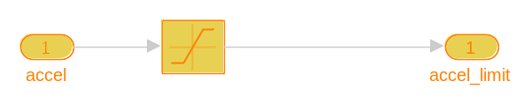
Show in Simulink (http://localhost:31415/matlab/feval/rmiobjnavigate?arguments=[%22Radar_Acc%22,%22:104%22])
표 5-20. Radar_Acc/ACC Classical/throttle /Subsystem Requirements
Link# | Link Description | Link Target (document name and location ID)
1. | "TSR_00500 Throttle 값의 급격한 증가 방지" | ../../../SJ/Desktop/data_acc/ACC System Safety Requirements.docx, at "Simulink_requirement_item_16" (http://localhost:31415/matlab/feval/rmi.navigate?arguments=[%22linktype_rmi_word%22,%22../../../SJ/Desktop/data_acc/ACC%20System%20Safety%20Requirements.docx%22,%22@Simulink_requirement_item_16%22,%22Radar_Acc%22])

표 5-21. Blocks in "Subsystem" that have requirements
Linked Object | Requirements Data
accel (http://localhost:31415/matlab/feval/rmiobjnavigate?arguments=[%22Radar_Acc%22,%22:105%22]) | 1.  "SSR_010501 Saturation:throttle"  ../../../SJ/Desktop/data_acc/ACC System Safety Requirements.docx, at "Simulink_requirement_item_19" (http://localhost:31415/matlab/feval/rmi.navigate?arguments=[%22linktype_rmi_word%22,%22../../../SJ/Desktop/data_acc/ACC%20System%20Safety%20Requirements.docx%22,%22@Simulink_requirement_item_19%22,%22Radar_Acc%22])
accel_limit (http://localhost:31415/matlab/feval/rmiobjnavigate?arguments=[%22Radar_Acc%22,%22:106%22]) | 1.  "SSR_010501 Saturation:throttle"  ../../../SJ/Desktop/data_acc/ACC System Safety Requirements.docx, at "Simulink_requirement_item_19" (http://localhost:31415/matlab/feval/rmi.navigate?arguments=[%22linktype_rmi_word%22,%22../../../SJ/Desktop/data_acc/ACC%20System%20Safety%20Requirements.docx%22,%22@Simulink_requirement_item_19%22,%22Radar_Acc%22])
Saturation (http://localhost:31415/matlab/feval/rmiobjnavigate?arguments=[%22Radar_Acc%22,%22:14%22]) | 1.  "SSR_010501 Saturation:throttle"  ../../../SJ/Desktop/data_acc/ACC System Safety Requirements.docx, at "Simulink_requirement_item_19" (http://localhost:31415/matlab/feval/rmi.navigate?arguments=[%22linktype_rmi_word%22,%22../../../SJ/Desktop/data_acc/ACC%20System%20Safety%20Requirements.docx%22,%22@Simulink_requirement_item_19%22,%22Radar_Acc%22])

.

System - Throttle
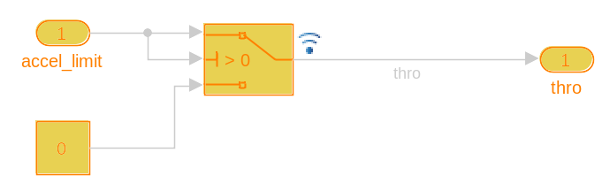
Show in Simulink (http://localhost:31415/matlab/feval/rmiobjnavigate?arguments=[%22Radar_Acc%22,%22:29%22])
표 5-22. Radar_Acc/ACC Classical/throttle /Throttle Requirements
Link# | Link Description | Link Target (document name and location ID)
1. | "TSR_00400 속도증가" | ../../../SJ/Desktop/data_acc/ACC System Safety Requirements.docx, at "Simulink_requirement_item_15" (http://localhost:31415/matlab/feval/rmi.navigate?arguments=[%22linktype_rmi_word%22,%22../../../SJ/Desktop/data_acc/ACC%20System%20Safety%20Requirements.docx%22,%22@Simulink_requirement_item_15%22,%22Radar_Acc%22])

표 5-23. Blocks in "Throttle" that have requirements
Linked Object | Requirements Data
accel_limit (http://localhost:31415/matlab/feval/rmiobjnavigate?arguments=[%22Radar_Acc%22,%22:30%22]) | 1.  "SSR_010401 Throttle"  ../../../SJ/Desktop/data_acc/ACC System Safety Requirements.docx, at "Simulink_requirement_item_17" (http://localhost:31415/matlab/feval/rmi.navigate?arguments=[%22linktype_rmi_word%22,%22../../../SJ/Desktop/data_acc/ACC%20System%20Safety%20Requirements.docx%22,%22@Simulink_requirement_item_17%22,%22Radar_Acc%22])
Constant (http://localhost:31415/matlab/feval/rmiobjnavigate?arguments=[%22Radar_Acc%22,%22:5%22]) | 1.  "SSR_010401 Throttle"  ../../../SJ/Desktop/data_acc/ACC System Safety Requirements.docx, at "Simulink_requirement_item_17" (http://localhost:31415/matlab/feval/rmi.navigate?arguments=[%22linktype_rmi_word%22,%22../../../SJ/Desktop/data_acc/ACC%20System%20Safety%20Requirements.docx%22,%22@Simulink_requirement_item_17%22,%22Radar_Acc%22])
Switch1 (http://localhost:31415/matlab/feval/rmiobjnavigate?arguments=[%22Radar_Acc%22,%22:21%22]) | 1.  "SSR_010401 Throttle"  ../../../SJ/Desktop/data_acc/ACC System Safety Requirements.docx, at "Simulink_requirement_item_17" (http://localhost:31415/matlab/feval/rmi.navigate?arguments=[%22linktype_rmi_word%22,%22../../../SJ/Desktop/data_acc/ACC%20System%20Safety%20Requirements.docx%22,%22@Simulink_requirement_item_17%22,%22Radar_Acc%22])
thro (http://localhost:31415/matlab/feval/rmiobjnavigate?arguments=[%22Radar_Acc%22,%22:32%22]) | 1.  "SSR_010402 Output:Throttle"  ../../../SJ/Desktop/data_acc/ACC System Safety Requirements.docx, at "Simulink_requirement_item_18" (http://localhost:31415/matlab/feval/rmi.navigate?arguments=[%22linktype_rmi_word%22,%22../../../SJ/Desktop/data_acc/ACC%20System%20Safety%20Requirements.docx%22,%22@Simulink_requirement_item_18%22,%22Radar_Acc%22])

.

6장. System Model Configuration
Source: | Model
Source Name: | Radar_Acc

표 6-1. Radar_Acc Configuration Set
Property | Value
Description
Components | [Radar_Acc Configuration Set.Components(1) [67] , Radar_Acc Configuration Set.Components(2) [69] , Radar_Acc Configuration Set.Components(3) [70] , Radar_Acc Configuration Set.Components(4) [72] , Radar_Acc Configuration Set.Components(5) [75] , Radar_Acc Configuration Set.Components(6) [77] , Radar_Acc Configuration Set.Components(7) [77] , Radar_Acc Configuration Set.Components(8) [78] , Radar_Acc Configuration Set.Components(9) [81] , Radar_Acc Configuration Set.Components(10) [82] ]
Name | Configuration
SimulationMode | normal
ConfigType | Model

표 6-2. Radar_Acc Configuration Set.Components [67] (1)
Property | Value
Name | Solver
Description
Components
StartTime | 0.0
StopTime | 10.0
AbsTol | auto
AutoScaleAbsTol | on
FixedStep | auto
InitialStep | auto
MaxNumMinSteps | -1
MaxOrder | 5
ZcThreshold | auto
ConsecutiveZCsStepRelTol | 10*128*eps
MaxConsecutiveZCs | 1000
ExtrapolationOrder | 4
NumberNewtonIterations | 1
MaxStep | auto
MinStep | auto
MaxConsecutiveMinStep | 1
RelTol | 1e-3
SolverMode | SingleTasking
EnableMultiTasking | off
EnableExplicitPartitioning | off
EnableConcurrentExecution | on
ConcurrentTasks | off
Solver | FixedStepDiscrete
SolverName | FixedStepDiscrete
SolverType | Fixed-step
SolverJacobianMethodControl | auto
ShapePreserveControl | DisableAll
ZeroCrossControl | UseLocalSettings
ZeroCrossAlgorithm | Nonadaptive
SolverResetMethod | Fast
PositivePriorityOrder | off
AutoInsertRateTranBlk | off
SampleTimeConstraint | Unconstrained
InsertRTBMode | Whenever possible
SampleTimeProperty
DecoupledContinuousIntegration | off
MinimalZcImpactIntegration | off

표 6-3. Radar_Acc Configuration Set.Components [67] (2)
Property | Value
Name | Data Import/Export
Description
Components
Decimation | 1
ExternalInput | [t, u]
FinalStateName | xFinal
InitialState | xInitial
LimitDataPoints | off
MaxDataPoints | 1000
LoadExternalInput | off
LoadInitialState | off
SaveFinalState | off
SaveCompleteFinalSimState | off
SaveFormat | Dataset
SaveOutput | on
SaveState | off
SignalLogging | on
DSMLogging | on
InspectSignalLogs | off
SaveTime | on
ReturnWorkspaceOutputs | off
StateSaveName | xout
TimeSaveName | tout
OutputSaveName | yout
SignalLoggingName | logsout
DSMLoggingName | dsmout
OutputOption | RefineOutputTimes
OutputTimes | []
ReturnWorkspaceOutputsName | out
Refine | 1
LoggingToFile | off
DatasetSignalFormat | timeseries
LoggingFileName | out.mat
LoggingIntervals | [-inf, inf]

표 6-4. Radar_Acc Configuration Set.Components [67] (3)
Property | Value
Name | Optimization
Description
Components
BlockReduction | off
BooleanDataType | on
ConditionallyExecuteInputs | on
DefaultParameterBehavior | Inlined
InlineParams | on
UseDivisionForNetSlopeComputation | off
UseFloatMulNetSlope | off
DefaultUnderspecifiedDataType | double
UseSpecifiedMinMax | off
InlineInvariantSignals | off
OptimizeBlockIOStorage | on
BufferReuse | on
GlobalBufferReuse | on
GlobalVariableUsage | Use global to hold temporary results
StrengthReduction | off
AdvancedOptControl
EnforceIntegerDowncast | on
ExpressionFolding | on
BooleansAsBitfields | off
BitfieldContainerType | uint_T
EnableMemcpy | on
MemcpyThreshold | 64
PassReuseOutputArgsAs | Individual arguments
PassReuseOutputArgsThreshold | 12
FoldNonRolledExpr | on
LocalBlockOutputs | on
RollThreshold | 5
StateBitsets | off
DataBitsets | off
ActiveStateOutputEnumStorageType | Native Integer
UseTempVars | off
ZeroExternalMemoryAtStartup | on
ZeroInternalMemoryAtStartup | on
InitFltsAndDblsToZero | off
NoFixptDivByZeroProtection | off
EfficientFloat2IntCast | on
EfficientMapNaN2IntZero | on
LifeSpan | inf
EvaledLifeSpan | Inf
MaxStackSize | Inherit from target
BufferReusableBoundary | on
SimCompilerOptimization | off
AccelVerboseBuild | off
OptimizeBlockOrder | speed
OptimizeDataStoreBuffers | on
BusAssignmentInplaceUpdate | on
DifferentSizesBufferReuse | on
OptimizationLevel | level2
OptimizationPriority | Balanced
OptimizationCustomize | off
LabelGuidedReuse | off

표 6-5. Radar_Acc Configuration Set.Components [67] (4)
Property | Value
Name | Diagnostics
Description
Components
RTPrefix | error
ConsistencyChecking | none
ArrayBoundsChecking | none
SignalInfNanChecking | error
StringTruncationChecking | error
SignalRangeChecking | error
ReadBeforeWriteMsg | EnableAllAsError
WriteAfterWriteMsg | EnableAllAsError
WriteAfterReadMsg | EnableAllAsError
AlgebraicLoopMsg | error
ArtificialAlgebraicLoopMsg | error
SaveWithDisabledLinksMsg | error
SaveWithParameterizedLinksMsg | error
CheckSSInitialOutputMsg | on
UnderspecifiedInitializationDetection | Simplified
MergeDetectMultiDrivingBlocksExec | error
CheckExecutionContextRuntimeOutputMsg | off
SignalResolutionControl | UseLocalSettings
BlockPriorityViolationMsg | error
MinStepSizeMsg | warning
TimeAdjustmentMsg | none
MaxConsecutiveZCsMsg | error
MaskedZcDiagnostic | warning
IgnoredZcDiagnostic | warning
SolverPrmCheckMsg | error
InheritedTsInSrcMsg | error
MultiTaskDSMMsg | error
MultiTaskCondExecSysMsg | error
MultiTaskRateTransMsg | error
SingleTaskRateTransMsg | none
TasksWithSamePriorityMsg | warning
SigSpecEnsureSampleTimeMsg | error
CheckMatrixSingularityMsg | error
IntegerOverflowMsg | error
Int32ToFloatConvMsg | warning
ParameterDowncastMsg | error
ParameterOverflowMsg | error
ParameterUnderflowMsg | error
ParameterPrecisionLossMsg | error
ParameterTunabilityLossMsg | error
FixptConstUnderflowMsg | none
FixptConstOverflowMsg | none
FixptConstPrecisionLossMsg | none
UnderSpecifiedDataTypeMsg | error
UnnecessaryDatatypeConvMsg | warning
VectorMatrixConversionMsg | error
InvalidFcnCallConnMsg | error
FcnCallInpInsideContextMsg | error
SignalLabelMismatchMsg | error
UnconnectedInputMsg | error
UnconnectedOutputMsg | error
UnconnectedLineMsg | error
UseOnlyExistingSharedCode | error
SFcnCompatibilityMsg | error
FrameProcessingCompatibilityMsg | error
UniqueDataStoreMsg | none
BusObjectLabelMismatch | error
RootOutportRequireBusObject | error
AssertControl | DisableAll
Echo
EnableOverflowDetection | off
AllowSymbolicDim | on
ModelReferenceIOMsg | error
ModelReferenceVersionMismatchMessage | none
ModelReferenceIOMismatchMessage | error
ModelReferenceCSMismatchMessage | none
ModelReferenceSimTargetVerbose | off
UnknownTsInhSupMsg | error
ModelReferenceDataLoggingMessage | error
ModelReferenceSymbolNameMessage | warning
ModelReferenceExtraNoncontSigs | error
StateNameClashWarn | warning
SimStateInterfaceChecksumMismatchMsg | warning
SimStateOlderReleaseMsg | error
InitInArrayFormatMsg | warning
StrictBusMsg | ErrorOnBusTreatedAsVector
BusNameAdapt | WarnAndRepair
NonBusSignalsTreatedAsBus | none
SFUnusedDataAndEventsDiag | warning
SFUnexpectedBacktrackingDiag | error
SFInvalidInputDataAccessInChartInitDiag | error
SFNoUnconditionalDefaultTransitionDiag | error
SFTransitionOutsideNaturalParentDiag | error
SFUnconditionalTransitionShadowingDiag | error
SFUnreachableExecutionPathDiag | error
SFUndirectedBroadcastEventsDiag | warning
SFTransitionActionBeforeConditionDiag | warning
SFOutputUsedAsStateInMooreChartDiag | error
SFTemporalDelaySmallerThanSampleTimeDiag | warning
SFUnconditionalPathOutOfParentDiag | error
SFSelfTransitionDiag | warning
SFExecutionAtInitializationDiag | warning
SFMachineParentedDataDiag | warning
SFUnreachableStateOrJunctionDiag | error
SFDanglingTransitionDiag | error
IntegerSaturationMsg | warning
AllowedUnitSystems | all
UnitsInconsistencyMsg | warning
AllowAutomaticUnitConversions | on
RCSCRenamedMsg | warning
RCSCObservableMsg | warning
ForceCombineOutputUpdateInSim | off

표 6-6. Radar_Acc Configuration Set.Components [67] (5)
Property | Value
Name | Hardware Implementation
Description
Components
ProdBitPerChar | 8
ProdBitPerShort | 16
ProdBitPerInt | 32
ProdBitPerLong | 32
ProdBitPerLongLong | 64
ProdBitPerFloat | 32
ProdBitPerDouble | 64
ProdBitPerPointer | 64
ProdBitPerSizeT | 64
ProdBitPerPtrDiffT | 64
ProdLargestAtomicInteger | Char
ProdLargestAtomicFloat | Float
ProdIntDivRoundTo | Zero
ProdEndianess | LittleEndian
ProdWordSize | 64
ProdShiftRightIntArith | on
ProdLongLongMode | off
ProdHWDeviceType | Intel->x86-64 (Windows64)
TargetBitPerChar | 8
TargetBitPerShort | 16
TargetBitPerInt | 32
TargetBitPerLong | 32
TargetBitPerLongLong | 64
TargetBitPerFloat | 32
TargetBitPerDouble | 64
TargetBitPerPointer | 32
TargetBitPerSizeT | 32
TargetBitPerPtrDiffT | 32
TargetLargestAtomicInteger | Char
TargetLargestAtomicFloat | None
TargetShiftRightIntArith | on
TargetLongLongMode | off
TargetIntDivRoundTo | Undefined
TargetEndianess | Unspecified
TargetWordSize | 32
TargetPreprocMaxBitsSint | 32
TargetPreprocMaxBitsUint | 32
TargetHWDeviceType | Specified
TargetUnknown | off
ProdEqTarget | on
UseEmbeddedCoderFeatures | on
UseSimulinkCoderFeatures | on

표 6-7. Radar_Acc Configuration Set.Components [67] (6)
Property | Value
Name | Model Referencing
Description
Components
UpdateModelReferenceTargets | IfOutOfDateOrStructuralChange
SkipRefExpFcnMdlSchedulingOrderCheck | off
EnableRefExpFcnMdlSchedulingChecks | on
CheckModelReferenceTargetMessage | error
EnableParallelModelReferenceBuilds | off
ParallelModelReferenceErrorOnInvalidPool | on
ParallelModelReferenceMATLABWorkerInit | None
ModelReferenceNumInstancesAllowed | Multi
PropagateVarSize | Infer from blocks in model
ModelDependencies
ModelReferencePassRootInputsByReference | on
ModelReferenceMinAlgLoopOccurrences | off
PropagateSignalLabelsOutOfModel | on
SupportModelReferenceSimTargetCustomCode | off

표 6-8. Radar_Acc Configuration Set.Components [67] (7)
Property | Value
Name | Simulation Target
Description
Components
SimCustomSourceCode
SimCustomHeaderCode
SimCustomInitializer
SimCustomTerminator
SimReservedNameArray
SimUserSources
SimUserIncludeDirs
SimUserLibraries
SimUserDefines
SFSimEnableDebug | off
SFSimOverflowDetection | on
SFSimEcho | on
SimBlas | on
SimCtrlC | on
SimExtrinsic | on
SimIntegrity | on
SimUseLocalCustomCode | off
SimParseCustomCode | on
SimBuildMode | sf_incremental_build
SimDataInitializer
SimGenImportedTypeDefs | off
CompileTimeRecursionLimit | 50
EnableRuntimeRecursion | on
MATLABDynamicMemAlloc | off
MATLABDynamicMemAllocThreshold | 65536
CustomSymbolStrEMXArray | nothing
CustomSymbolStrEMXArrayFcn | nothing

표 6-9. Radar_Acc Configuration Set.Components [67] (8)
Property | Value
Name | Code Generation
SystemTargetFile | ert.tlc
HardwareBoard | None
TLCOptions
CodeGenDirectory
GenCodeOnly | off
MakeCommand | make_rtw
GenerateMakefile | on
PackageGeneratedCodeAndArtifacts | off
PackageName
TemplateMakefile | ert_default_tmf
PostCodeGenCommand
Description | Embedded Coder
GenerateReport | on
SaveLog | off
RTWVerbose | on
RetainRTWFile | off
ProfileTLC | off
TLCDebug | off
TLCCoverage | off
TLCAssert | off
ProcessScriptMode | Default
ConfigurationMode | Optimized
ProcessScript | ert_make_rtw_hook
ConfigurationScript
ConfigAtBuild | off
RTWUseLocalCustomCode | off
RTWUseSimCustomCode | off
CustomSourceCode
CustomHeaderCode
CustomInclude
CustomSource
CustomLibrary
CustomDefine
CustomLAPACKCallback
CustomFFTCallback
CustomInitializer
CustomTerminator
Toolchain | Automatically locate an installed toolchain
BuildConfiguration | Faster Builds
CustomToolchainOptions
IncludeHyperlinkInReport | on
LaunchReport | on
RecursionLimit | 50
PortableWordSizes | off
GenerateErtSFunction | off
CreateSILPILBlock | None
CodeExecutionProfiling | off
CodeExecutionProfileVariable | executionProfile
CodeProfilingSaveOptions | SummaryOnly
CodeProfilingInstrumentation | off
CodeCoverageSettings | Radar_Acc Configuration Set.Components(8).CodeCoverageSettings [83]
SILDebugging | off
TargetLang | C
IncludeERTFirstTime | off
GenerateTraceInfo | on
GenerateTraceReport | on
GenerateTraceReportSl | on
GenerateTraceReportSf | on
GenerateTraceReportEml | on
GenerateCodeInfo | off
GenerateWebview | off
GenerateCodeMetricsReport | off
GenerateCodeReplacementReport | off
RTWCompilerOptimization | off
ObjectivePriorities
RTWCustomCompilerOptimizations
CheckMdlBeforeBuild | Off
CustomRebuildMode | OnUpdate
DataInitializer
Components | [Radar_Acc Configuration Set.Components(8).Components(1) [83] , Radar_Acc Configuration Set.Components(8).Components(2) [85] ]

표 6-10. Radar_Acc Configuration Set.Components [67] (9)
Property | Value
Description | Simulink Coverage Configuration Component
Components
Name | Simulink Coverage
CovEnable | off
CovScope | EntireSystem
CovIncludeTopModel | on
RecordCoverage | off
CovPath | /
CovSaveName | covdata
CovCompData
CovMetricSettings | dwe
CovFilter
CovHTMLOptions
CovNameIncrementing | off
CovHtmlReporting | off
CovForceBlockReductionOff | on
CovEnableCumulative | on
CovSaveCumulativeToWorkspaceVar | off
CovSaveSingleToWorkspaceVar | off
CovCumulativeVarName | covCumulativeData
CovCumulativeReport | off
CovSaveOutputData | on
CovOutputDir | slcov_output/$ModelName$
CovDataFileName | $ModelName$_cvdata
CovShowResultsExplorer | on
CovReportOnPause | on
CovModelRefEnable | off
CovModelRefExcluded
CovExternalEMLEnable | on
CovSFcnEnable | on
CovBoundaryAbsTol | 1.0000e-05
CovBoundaryRelTol | 0.0100
CovUseTimeInterval | off
CovStartTime | 0
CovStopTime | 0
CovMetricStructuralLevel | Decision
CovMetricLookupTable | off
CovMetricSignalRange | off
CovMetricSignalSize | off
CovMetricObjectiveConstraint | off
CovMetricSaturateOnIntegerOverflow | off
CovMetricRelationalBoundary | off
CovLogicBlockShortCircuit | off
CovUnsupportedBlockWarning | on
CovHighlightResults | off
CovMcdcMode | Masking

표 6-11. Radar_Acc Configuration Set.Components [67] (10)
Property | Value
Description | HDL Coder custom configuration component
Components
Name | HDL Coder

표 6-12. Radar_Acc Configuration Set.Components(8) [78] .CodeCoverageSettings
Property | Value
TopModelCoverage | off
ReferencedModelCoverage | off
CoverageTool | None

표 6-13. Radar_Acc Configuration Set.Components(8).Components [81] (1)
Property | Value
Name | Code Appearance
Description
Components
ForceParamTrailComments | on
GenerateComments | on
CommentStyle | Auto
IgnoreCustomStorageClasses | off
IgnoreTestpoints | off
IncHierarchyInIds | off
MaxIdLength | 31
ShowEliminatedStatement | on
OperatorAnnotations | on
IncAutoGenComments | off
SimulinkDataObjDesc | on
SFDataObjDesc | on
MATLABFcnDesc | off
IncDataTypeInIds | off
PrefixModelToSubsysFcnNames | on
MangleLength | 5
SharedChecksumLength | 8
CustomSymbolStr | $R$N$M
CustomSymbolStrGlobalVar | $R$N$M
CustomSymbolStrType | $N$R$M_T
CustomSymbolStrField | $N$M
CustomSymbolStrFcn | $R$N$M$F
CustomSymbolStrSimulinkFcn | $R$N
CustomSymbolStrFcnArg | rt$I$N$M
CustomSymbolStrBlkIO | rtb_$N$M
CustomSymbolStrTmpVar | $N$M
CustomSymbolStrMacro | $R$N$M
CustomSymbolStrUtil | $N$C
CustomSymbolStrEmxType | emxArray_$M$N
CustomSymbolStrEmxFcn | emx$M$N
CustomUserTokenString
CustomCommentsFcn
DefineNamingRule | None
DefineNamingFcn
ParamNamingRule | None
ParamNamingFcn
SignalNamingRule | None
SignalNamingFcn
InsertBlockDesc | on
InsertPolySpaceComments | off
SimulinkBlockComments | on
BlockCommentType | BlockPathComment
StateflowObjectComments | off
MATLABSourceComments | off
EnableCustomComments | off
InternalIdentifier | Shortened
InlinedPrmAccess | Literals
ReqsInCode | on
UseSimReservedNames | off
ReservedNameArray

표 6-14. Radar_Acc Configuration Set.Components(8).Components [81] (2)
Property | Value
Name | Target
Description
Components
IsERTTarget | on
TargetLibSuffix
TargetPreCompLibLocation
GenFloatMathFcnCalls | NOT IN USE
TargetLangStandard | C99 (ISO)
TargetFunctionLibrary | NOT IN USE
CodeReplacementLibrary | None
UtilityFuncGeneration | Auto
ERTMultiwordTypeDef | System defined
MultiwordTypeDef | System defined
ERTMultiwordLength | 256
MultiwordLength | 256
DynamicStringBufferSize | 256
GenerateFullHeader | on
InferredTypesCompatibility | off
ExistingSharedCode
SharedCodeLocation
GenerateSampleERTMain | on
GenerateTestInterfaces | off
ModelReferenceCompliant | on
ParMdlRefBuildCompliant | on
CompOptLevelCompliant | on
ConcurrentExecutionCompliant | on
IncludeMdlTerminateFcn | off
CombineOutputUpdateFcns | on
CombineSignalStateStructs | off
SuppressErrorStatus | on
ERTFirstTimeCompliant | on
IncludeFileDelimiter | Auto
ERTCustomFileBanners | on
SupportAbsoluteTime | off
LogVarNameModifier | rt_
MatFileLogging | off
MultiInstanceERTCode | off
CodeInterfacePackaging | Nonreusable function
SupportNonFinite | off
SupportComplex | on
PurelyIntegerCode | off
SupportContinuousTime | off
SupportNonInlinedSFcns | off
RemoveDisableFunc | off
RemoveResetFunc | on
SupportVariableSizeSignals | off
ParenthesesLevel | Maximum
CastingMode | Nominal
GenerateClassInterface | off
ModelStepFunctionPrototypeControlCompliant | on
CPPClassGenCompliant | on
GRTInterface | off
GenerateAllocFcn | off
UseToolchainInfoCompliant | on
GenerateSharedConstants | on
LUTObjectStructOrderExplicitValues | Size,Breakpoints,Table
LUTObjectStructOrderEvenSpacing | Size,Breakpoints,Table
ERTHeaderFileRootName | $R$E
ERTSourceFileRootName | $R$E
ERTDataFileRootName | $R_data
GenerateASAP2 | off
ExtMode | off
ExtModeTransport | 0
ExtModeStaticAlloc | off
ExtModeStaticAllocSize | 1000000
ExtModeTesting | off
ExtModeMexFile | ext_comm
ExtModeMexArgs
ExtModeIntrfLevel | Level1
InlinedParameterPlacement | NonHierarchical
TargetOS | BareBoardExample
MultiInstanceErrorCode | Error
RootIOFormat | Individual arguments
RTWCAPISignals | off
RTWCAPIParams | off
RTWCAPIStates | off
RTWCAPIRootIO | off
ERTSrcFileBannerTemplate | ert_code_template.cgt
ERTHdrFileBannerTemplate | ert_code_template.cgt
ERTDataSrcFileTemplate | ert_code_template.cgt
ERTDataHdrFileTemplate | ert_code_template.cgt
ERTCustomFileTemplate | example_file_process.tlc
EnableDataOwnership | off
SignalDisplayLevel | 10
ParamTuneLevel | 10
GlobalDataDefinition | Auto
DataDefinitionFile | global.c
GlobalDataReference | Auto
ERTFilePackagingFormat | Modular
RateTransitionBlockCode | Inline
DataReferenceFile | global.h
PreserveExpressionOrder | on
PreserveIfCondition | on
ConvertIfToSwitch | on
PreserveExternInFcnDecls | on
PreserveStaticInFcnDecls | on
SuppressUnreachableDefaultCases | on
EnableSignedLeftShifts | on
EnableSignedRightShifts | on
IndentStyle | K&R
IndentSize | 2
NewlineStyle | Default
EnableUserReplacementTypes | off
ReplacementTypes | Radar_Acc Configuration Set.Components(8).Components(2).ReplacementTypes [89]
MaxIdInt32 | MAX_int32_T
MinIdInt32 | MIN_int32_T
MaxIdUint32 | MAX_uint32_T
MaxIdInt16 | MAX_int16_T
MinIdInt16 | MIN_int16_T
MaxIdUint16 | MAX_uint16_T
MaxIdInt8 | MAX_int8_T
MinIdInt8 | MIN_int8_T
MaxIdUint8 | MAX_uint8_T
BooleanTrueId | true
BooleanFalseId | false
TypeLimitIdReplacementHeaderFile
MemSecPackage | --- None ---
MemSecDataConstants | Default
MemSecDataIO | Default
MemSecDataInternal | Default
MemSecDataParameters | Default
MemSecFuncInitTerm | Default
MemSecFuncExecute | Default
MemSecFuncSharedUtil | Default

표 6-15. Radar_Acc Configuration Set.Components(8).Components(2) [85] .ReplacementTypes
Field | Value
double
single
int32
int16
int8
uint32
uint16
uint8
boolean
int
uint
char

표 6-16. HDL Coder
Property | Value
HDLSubsystem | Radar_Acc
Workflow | Generic ASIC/FPGA
TargetPlatform
ReferenceDesign
ReferenceDesignPath
CoeffPrefix | coeff
InputType | std_logic_vector
OutputType | Same as input type
ScalarizePorts | off
CoeffMultipliers | Multiplier
ResetType | Asynchronous
FIRAdderStyle | linear
MultiplierInputPipeline | 0
MultiplierOutputPipeline | 0
FoldingFactor | 1
NumMultipliers | -1
OptimizeForHDL | off
TimingControllerPostfix | _tc
OptimizeTimingController | on
TimingControllerArch | default
CastBeforeSum | on
CheckHDL | off
EnablePrefix | enb
ClockEnableInputPort | clk_enable
ClockEnableOutputPort | ce_out
ClockInputPort | clk
ClockEdge | Rising
ResetInputPort | reset
SimulatorFlags
HDLCompileFilePostfix | _compile.do
HDLCompileInit | vlib %s\n
HDLCompileTerm
HDLCompileVerilogCmd | vlog %s %s\n
HDLCompileVHDLCmd | vcom %s %s\n
EnableForGenerateLoops | on
HDLMapFilePostfix | _map.txt
HDLMapSeparator
HDLSimCmd | vsim -novopt %s.%s\n
HDLSimFilePostfix | _sim.do
HDLSimProjectFilePostfix | _init.do
HDLSimInit | onbreak resume\nonerror resume\n
HDLSimProjectCmd | project addfile %s\n
HDLSimProjectTerm | project compileall\n
HDLSimProjectInit | project new . %s work\n
HDLSimTerm | run -all\n
HDLSimViewWaveCmd | add wave sim:%s\n
HDLSynthTool | None
HDLSynthCmd
HDLSynthFilePostfix
HDLSynthInit
HDLSynthLibCmd
HDLSynthLibSpec
HDLSynthTerm
ReservedWordPostfix | _rsvd
BlockGenerateLabel | _gen
VHDLLibraryName | work
UseSingleLibrary | off
VHDLArchitectureName | rtl
ClockProcessPostfix | _process
ComplexImagPostfix | _im
ComplexRealPostfix | _re
EntityConflictPostfix | _block
InstancePrefix | u_
InstancePostfix
InstanceGenerateLabel | _gen
OutputGenerateLabel | outputgen
PackagePostfix | _pkg
SplitEntityArch | off
SplitEntityFilePostfix | _entity
SplitArchFilePostfix | _arch
VectorPrefix | vector_of_
ClockInputs | Single
TriggerAsClock | off
ConditionalizePipeline | off
InferControlPorts | off
UseRisingEdge | off
TargetDirectory | hdlsrc
TargetSubdirectory | Model
EDAScriptGeneration | on
AddInputRegister | on
AddOutputRegister | on
AddPipelineRegisters | off
PipelinePostfix | _pipe
InputPort | filter_in
OutputPort | filter_out
FracDelayPort | filter_fd
Name | filter
RemoveResetFrom | None
ResetAssertedLevel | Active-high
ReuseAccum | off
ScaleWarnBits | 3
SerialPartition | -1
DALUTPartition | -1
DARadix | 2
CoefficientSource | Internal
CoefficientMemory | Registers
InputComplex | off
AddRatePort | off
InputDataType
GenerateHDLCode | on
GenerateModel | on
GenerateTB | off
GenerateCEGenModel | off
Traceability | off
ResourceReport | off
OptimizationReport | off
ErrorCheckReport | on
HDLGenerateWebview | off
IPCoreReport | off
Recommendations | off
RequirementComments | on
Backannotation | off
HierarchicalDistPipelining | off
PreserveDesignDelays | off
ClockRatePipelining | on
CRPWithoutFlattening | on
IncreaseCRPBudget | on
AdaptivePipelining | on
MinDelaysRequiredAtLocalMultirateOutput | 1
ClockRatePipelineOutputPorts | off
CriticalPathEstimation | off
optimizeserializer | on
shareequalwl | on
sharedmulsign | Signed
MultiplierPromotionThreshold | 0
RoutingFudgeFactor | 0.5000
OptimizationCompatibilityCheck | off
NumCriticalPathsEstimated | 1
CriticalPathEstimationFile | criticalPathEstimated
HardwarePipeliningCharacterizationFile
HighlightFeedbackLoops | on
HighlightFeedbackLoopsFile | highlightFeedbackLoop
HighlightClockRatePipeliningDiagnostic | on
HighlightClockRatePipeliningFile | highlightClockRatePipelining
DistributedPipeliningBarriers | on
DistributedPipeliningBarriersFile | highlightDistributedPipeliningBarriers
BlocksWithNoCharacterizationFile | highlightCriticalPathEstimationOffendingBlocks
AXIStreamingTransformFeatureControl | off
SerializerRatioThreshold | 8192
RetimingCP | off
RetimingCPFile | highlightRetimingCP
ClearHighlightingFile | clearhighlighting
FunctionallyEquivalentRetiming | on
DistributedPipeliningPriority | NumericalIntegrity
RetimingDetails | on
CriticalPathDetails | off
SignalNamesMangling | off
GuidedRetiming | off
LatencyConstraint | 0
ReduceMatchingDelays | on
OptimizationData
CPGuidanceFile
CPAnnotationFile
HandleAtomicSubsystem | on
OptimizeMdlGen | on
MulticyclePathInfo | off
MulticyclePathConstraints | off
FloatingPointTargetConfiguration
GenerateTargetComps | on
NativeFloatingPoint | off
FPToleranceValue | 1.0000e-07
FPToleranceStrategy | DEFAULT
nfpLatency | DEFAULT
nfpDenormals | DEFAULT
AlteraBackwardIncompatibleSinCosPipeline | off
FamilyDevicePackageSpeed
ToolName
SynthesisToolChipFamily
SynthesisToolDeviceName
SynthesisToolPackageName
SynthesisToolSpeedValue
SynthesisTool
SynthesisProjectAdditionalFiles
SimulationLibPath
XilinxSimulatorLibPath
AdderSharingMinimumBitwidth | 0
MultiplierSharingMinimumBitwidth | 0
MultiplyAddSharingMinimumBitwidth | 0
ShareAdders | off
ShareMultipliers | on
ShareMultiplyAdds | on
ShareMATLABBlocks | on
ShareAtomicSubsystems | on
ShareFloatingPointIPs | on
PipelinedSharing | on
OptimizeCRPSharingRegisters | on
ClockRatePipeliningBudgetCheck | off
EnableFPGAWorkflow | off
FPGAWorkflowParameters
GainMultipliers | Multiplier
ProductOfElementsStyle | linear
UserComment
CustomFileHeaderComment
CustomFileFooterComment
DateComment | on
SafeZeroConcat | on
SumOfElementsStyle | linear
TargetLanguage | VHDL
Oversampling | 1
ClockRatePipeliningFraction | 1
Verbosity | 1
TestBenchName | filter_tb
MultifileTestBench | off
IgnoreDataChecking | 0
TestBenchPostfix | _tb
TestBenchDataPostfix | _data
TestBenchStimulus
TestBenchUserStimulus
TestBenchFracDelayStimulus
TestBenchCoeffStimulus
TestBenchRateStimulus
ForceClockEnable | on
MinimizeClockEnables | off
MinimizeGlobalResets | off
NoResetInitializationMode | InsideModule
NoResetInitScript | noresetinitscript.tcl
ComplexMulElaboration | MultiplyAddBlock
FlattenBus | off
TestBenchClockEnableDelay | 1
ForceClock | on
ClockHighTime | 5
ClockLowTime | 5
HoldTime | 2
InputDataInterval | 0
ForceReset | on
ErrorMargin | 4
HoldInputDataBetweenSamples | on
InitializeTestBenchInputs | off
ResetLength | 2
TestBenchReferencePostFix | _ref
GenerateValidationModel | off
RAMMappingThreshold | 256
MapPipelineDelaysToRAM | off
RemoveRedundantCounters | on
ReplaceUnitDelayWithIntegerDelay | on
ConcatenateDelays | on
MergeDelaysOnFanouts | on
FoldDelaysToConstant | on
RAMArchitecture | WithClockEnable
InlineMATLABBlockCode | off
InlineHDLCode | off
MaskParameterAsGeneric | off
BalanceDelays | on
TargetFrequency | 0
ExtraEffortMargin | 1
MaxOversampling | Inf
MaxComputationLatency | 1
MultiplierPartitioningThreshold | Inf
TreatDelayBalancingFailureAs | Error
TransformNonZeroInitValDelay | on
DelayElaborationLimit | 20
GenerateCoSimBlock | off
HDLCodeCoverage | off
GenerateHDLTestBench | on
GenerateCoSimModel | None
GenerateSVDPITestBench | None
SimulationTool | Mentor Graphics Modelsim
CoSimModelSetup | CosimBlockAndDut
SynthesisOnDirective
SynthesisOffDirective
LoopUnrolling | off
InlineConfigurations | on
UseAggregatesForConst | off
UseVerilogTimescale | on
VerilogFileExtension | .v
SystemVerilogFileExtension | .sv
VHDLFileExtension | .vhd
CodeGenerationOutput | GenerateHDLCode
GeneratedModelName
GeneratedModelNamePrefix | gm_
UseDotLayout | off
ShowCodeGenPIR | off
SerializeModel | 0
SerializeIO | 0
UseSLAutoRoute | on
UseAutoPlace | on
HighlightAncestors | on
HighlightColor | cyan
InitializeBlockRAM | on
InitializeRealPort | off
MapVectorPortToStream | off
UseFileIOInTestBench | on
TurnkeyWorkflow | off
AlteraWorkflow | off
GenerateFILBlock | off
CoSimLibPostfix | _cosim
TestBenchInitializeInputs | off
MinimizeIntermediateSignals | off
GenerateCodeInfo | off
GatewayoutWithDTC | off
IncrementalCodeGenForTopModel | off
HDLWFSmartbuild | on
HDLCodingStandard | None
HDLCodingStandardCustomizations
ReferenceDesignParameter
HDLLintTool | None
HDLLintInit
HDLLintTerm
HDLLintCmd
ModulePrefix
DetectBlackBoxNameCollision | Warning
PIRTB | on
PIRTC | off
EmitNetlist | off
UsePipelinedToolboxFunctions | on
savepirtoscript | off
ConcatenateHDLModules | off
AMS | off
ML2PIR | off
EnableTestpoints | off
TraceabilityStyle | Line Level
lineLevelTraceability | on
commentTraceability | off
TreatRealsInGeneratedCodeAs | Error
EnumEncodingScheme | default
BuildToProtectModel | off
OptimizeConstants | on

7장. Glossary
Atomic Subsystem. A subsystem treated as a unit by an implementation of the design documented in this report. The implementation computes the outputs of all the blocks in the atomic subsystem before computing the next block in the parent system's block execution order (sorted list).
Block Diagram. A Simulink block diagram represents a set of simultaneous equations that relate a system or subsystem's inputs to its outputs as a function of time. Each block in the diagram represents an equation of the form y = f(t, x, u) where t is the current time, u is a block input, y is a block output, and x is a system state (see the Simulink documentation for information on the functions represented by the various types of blocks that make up the diagram). Lines connecting the blocks represent dependencies among the blocks, i.e., inputs whose current values are the outputs of other blocks. An implementation of a design described in this document computes a root or atomic system's outputs at each time step by computing the outputs of the blocks in an order determined by block input/output dependencies.
Block Parameter. A variable that determines the output of a block along with its inputs, for example, the gain parameter of a Gain block.
Block Execution Order. The order in which Simulink evaluates blocks during simulation of a model. The block execution order determined by Simulink ensures that a block executes only after all blocks on whose outputs it depends are executed.
Checksum. A number that indicates whether different versions of a model or atomic subsystem differ functionally or only cosmetically. Different checksums for different versions of the same model or subsystem indicate that the versions differ functionally.
Design Variable. A symbolic (MATLAB) variable or expression used as the value of a block parameter. Design variables allow the behavior of the model to be altered by altering the value of the design variable.
Signal. A block output, so-called because block outputs typically vary with time.
Virtual Subsystem. A subsystem that is purely graphical, i.e., is intended to reduce the visual complexity of the block diagram of which it is a subsystem. An implementation of the design treats the blocks in the subsystem as part of the first nonvirtual ancestor of the virtual subsystem (see Atomic Subsystem).

8장. About this Report

Report Overview
This report describes the design of the Radar_Acc system. The report was generated automatically from a Simulink model used to validate the design. It contains the following sections:
Model Version. Specifies information about the version of the model from which this design description was generated. Includes the model checksum, a number that indicates whether different versions of the model differ functionally or only cosmetically. Different checksums for different versions indicate that the versions differ functionally.
Root System. Describes the design's root system.
Subsystems. Describes each of the design's subsystems.
Design Variables. Describes system design variables, i.e., MATLAB variables and expressions used as block parameter values.
System Model Configuration. Lists the configuration parameters, e.g., start and stop time, of the model used to simulate the system described by this report.
Requirements. Shows design requirements associated with elements of the design model. This section appears only if the design model contains requirements links.
Glossary. Defines Simulink terms used in this report.

Root System Description
This section describes a design's root system. It contains the following sections:
Diagram. Simulink block diagram that represents the algorithm used to compute the root system's outputs.
Description. Description of the root system. This section appears only if the model's root system has a Documentation property or a Doc block.
Interface. Name, data type, width, and other properties of the root system's input and output signals. The number of the block port that outputs the signal appears in angle brackets appended to the signal name. This section appears only if the root system has input or output ports.
Blocks. This section has two subsections:
• Parameters. Describes key parameters of blocks in the root system. This section also includes graphical and/or tabular representations of lookup table data used by lookup table blocks, i.e., blocks that use lookup tables to compute their outputs.
• Block Execution Order. Order in which blocks must be executed at each time step in order to ensure that each block's inputs are available when it executes.
State Charts. Describes state charts used in the root system. This section appears only if the root system contains Stateflow blocks.

Subsystem Descriptions
This section describes a design's subsystems. Each subsystem description contains the following sections:
Checksum. This section appears only if the subsystem is an atomic subsystem. The checksum indicates whether the version of the model subsystem used to generate this report differs functionally from other versions of the model subsystem. If two model checksums differ, the corresponding versions of the model differ functionally.
Diagram. Simulink block diagram that graphically represents the algorithm used to compute the subsystem's outputs.
Description. Description of the subsystem. This section appears only if the subsystem has a Documentation property or contains a Doc block.
Interface. Name, data type, width, and other properties of the subsystem's input and output signals. The number of the block port that outputs the signal appears in angle brackets appended to the signal name. This section appears only if the subsystem is atomic and has input or output ports.
Blocks. Blocks that this subsystem contains. This section has two subsections:
• Parameters. Key parameters of blocks in the subsystem. This section also includes graphical and/or tabular representations of lookup table data used by lookup table blocks, blocks that use lookup tables to compute their outputs.
• Block Execution Order. Order in which the subsystem's blocks must be executed at each time step in order to ensure that each block's inputs are available when the block executes .This section appears only if the subsystem is atomic. Note: in Acrobat(PDF) reports, the number in square brackets next to the block name is a hyperlink to the block parameter table. The number has no model significance.
State Charts. Describes state charts used in the subsystem. This section appears only if the root system contains Stateflow blocks.

State Chart Descriptions
This section describes the state machines used by Stateflow blocks to compute their outputs, i.e., Stateflow blocks. Each state machine description contains the following sections:
Chart. Diagram representing the state machine.
States. Describes the state machine's states. Each state description includes the state's diagram and diagrams and/or descriptions of graphical functions, Simulink functions, truth tables, and MATLAB functions parented by the state.
Transitions. Transitions between the state machine's states. Each transition description specifies the values of key transition properties. Appears only if a transition has properties that do not appear on the chart.
Junctions. Transition junctions. Each junction description specifies the values of key junction properties. Appears only if a junction has properties that do not appear on the chart.
Events. Events that trigger state transitions. Each event description specifies the values of key event properties.
Data. Data types and other properties of the Stateflow block's inputs, outputs, and other state machine data.
Targets. Executable implementations of the state machine used to compute the outputs of the corresponding Stateflow block.
MATLAB Supporting Functions. List of functions invoked by MATLAB functions defined in the chart.

